13A

San Bernardino Community College District

Strategic Plan 2010-14

Draft
April 25, 2010

District Strategic Planning Committee

Table of Contents

Section Page
1. Preamble 3
2. District and College Foundational Statements 7
3. Effectiveness and Impact Indicators 9
4. Strategic Issues 15
5. Major Planning Assumptions 21
6. A Brief Introduction to Planning Terminology 22
7. Overview of Strategic Directions, Goals, and Alignment with College Plans 24
8. District Strategic Directions, Goals, and Objectives 26
9. Long-Range Financial Plan and Forecast 35
10. Characteristics of the Colleges 38
11. Planning Context: Information from the Environmental Scan 47
12. Glossary 68

Preamble

Main Purposes of the District Strategic Plan

The main purposes of the District Strategic Plan (DSP) are as follows:
- It provides an integrated framework within which the Board, the District, and the Colleges can work toward coordinated goals over the long term.
- It facilitates effective pursuit of the mission of the District.
- It promotes efficient use of District and College resources in the long term.
- It helps the District and Colleges anticipate challenges and take advantage of opportunities.
- It guides further planning and decision-making at all levels.
The DSP is thus a crucial contributor to the ongoing improvement and continuing success of the District and its Colleges.

Background and Process

In twice-monthly meetings since October 2009, the 18 members of the collegial-consultation District Strategic Planning Committee (DSPC) have been developing, as required by the Accrediting Commission, a “formal and regularly evaluated district strategic plan that both acknowledges input [from] and aligns with the colleges[’] educational plan[s] and serves as a guide for planning at the college level.” In part because of the Commission’s emphasis on input from and alignment with the Colleges’ strategic and educational master plans, and on guidance of further College planning, the DSPC has drawn heavily on the content of existing College plans in this initial edition of the DSP. (After evaluation of the 2009-10 DSP, the Committee will refine the Plan further to include integration of KVCR and EDCT, more research, and other features; see Evaluation and Revision of the Plan below.) However, members have also reviewed and discussed numerous other sources of information, including the following:
- Board Imperatives and Institutional Goals, 2009-10 | - The Colleges’ missions and other foundational statements
- California Community Colleges Strategic Plan | - The Accrediting Commission’s Rubric for evaluating Planning
- Statistics on enrollment patterns and on students and their performance | - Information about our service areas from an updated environmental scan
- Subcommittee reports on important strategic issues related to higher education

Based on thoughtful consideration and spirited discussion of all the information provided, the DSPC developed and refined a draft set of Strategic Directions and Goals. On March 1, 2010, the Chancellor sent the Committee’s recommended Strategic Directions and Goals to all employees, with a structured request for feedback and for specific ideas on concrete steps the District should take. Respondents had the option of emailing their comments or giving them to their representative on the Committee. The DSPC also hosted three open forums—one at each College and one at the District Offices—in March to answer questions and receive feedback. Finally, a request was sent to the Presidents of the Academic, Classified, and Student Senates of both Colleges to gather additional feedback at their next scheduled meetings.

After serious consideration of all feedback received, and much more discussion, the DSPC drafted objectives for each Goal to fulfill one or more of five main purposes:
  - Provide needed District support to both Colleges in pursuing and achieving their own goals.
  - Coordinate, or place a District umbrella over, analogous sets of goals and objectives that already exist at both Colleges.
  - Guide further planning at both Colleges.
  - Establish or enhance a District-level operation to advance a District Goal.
  - Fill a gap in the Colleges’ planning.
To each objective, the DSPC added a tentative timeline, a responsible point person or group, a set of measures of progress, and a set of suggested actions.

In late April 2010, the Chancellor distributed to all employees the full draft of the DSP, with a request once again for feedback in one of four ways: by email, in one of two open forums (one at each College), through members of the Committee, and (for employees at the District offices, KVCR, and EDCT) through staff meetings.

[*Note: This section will be revised in the final version of the Plan to complete the description of the process. The Committee is scheduled to consider all feedback received by the deadline at its May 7, 2010 meeting; it will make any changes as appropriate to strengthen the Plan; and then it is scheduled to submit the final version to the Chancellor at its meeting of May 14, 2010.*]

The DSPC submitted the final version of the Plan to the Chancellor on XXXX X, 2010.

Evaluation and Revision of the Plan

Schedule
The full evaluation of the 2009-10 District Strategic Plan (DSP) will take place in 2010-11, with implementations of any necessary revisions to follow in Fall 2011. Subsequent full evaluations of the DSP, followed by implementation of any necessary revisions, will occur triennially beginning in Fall 2013.

Annual Progress Reports
In the Spring semester of each year beginning in 2012, each Vice Chancellor, College President, and Executive Director will prepare and disseminate a progress report on those District Goals and Objectives applicable to the organization that he or she supervises. College Presidents will prepare their progress reports in appropriate consultation with the constituency groups on their respective campuses; Vice Chancellors and Executive Directors will prepare their progress reports in appropriate consultation with staff in their respective operations. In each year other than a full-evaluation year, Collegiate Cabinet will review these progress reports, and may recommend that a full evaluation take place earlier than originally scheduled.

Evaluation Responsibility
The original District Strategic Planning Committee (DSPC), members of which were appointed for a two-year term, will conduct the full evaluation of the 2009-10 DSP. For each subsequent triennial cycle, the Chancellor will identify and convene a broadly representative body that will function as a successor DSPC, chaired by the Chancellor or designee, to conduct the evaluation.

Evaluation of the 2009-10 DSP
In the full evaluation of the 2009-10 DSP, the DSPC will:
- Gather additional research and other information it deems necessary for an exemplary DSP.
- Based in part on the additional information, identify significant changes needed, if any, in the 2009-10 DSP, and make those changes in a revised DSP.
- Solicit input and/or feedback on the revised Plan, and incorporate that input and/or feedback as appropriate.
- Submit the final revised DSP to the Chancellor, who will submit it to the Board for approval.
- Improvements reflected in the revised DSP will be implemented and documented beginning in Fall 2011.

The Chancellor’s Office will ensure that the revised DSP is posted on the District website and otherwise widely disseminated.

Triennial Evaluation of the DSP
At a minimum, each subsequent triennial full evaluation cycle will consist of the following steps:
- The successor DSPC will review the most recent set of Annual Progress Reports.
- Each person or group responsible for completion of an Objective will submit a status report on that Objective to the successor DSPC. [Such responsible parties have not yet been designated—Ed.]
- The SBVC College Council and the CHC Educational Master Planning Committee will submit to the successor DSPC progress reports on the Colleges’ respective strategic and educational master plans.
- District and College technology planning groups and facilities planning groups will submit to the successor DSPC progress reports on their respective plans.
- A Research Subcommittee or other group with appropriate expertise will provide updated information on environmental scan results, effectiveness and impact indicators, and other research as needed.
- The successor DSPC will compile and disseminate a Three-Year Status Report on the DSP as a whole, which will include its conclusions on which Objectives and/or Goals of the DSP have been achieved and should therefore be retired, and which should remain in the DSP for further work.
- The successor DSPC will review any changes in the ACCJC Accreditation Standards since the last triennial evaluation, and the resolution status of any outstanding ACCJC recommendations to either College.
- Based on the information available, the successor DSPC will update the District planning assumptions.
- The successor DSPC will determine what additions or modifications to the Strategic Directions, Goals, Objectives, and/or other elements of the DSP are required, and draft a revised DSP accordingly.
- The successor DSPC will solicit feedback on the draft widely, and incorporate that feedback as appropriate.
- The successor DSPC will submit the final revised DSP to the Chancellor, who will submit it to the Board for approval.
- Improvements reflected in the revised DSP will be implemented and documented beginning in the following Fall semester.
- The Chancellor’s Office will ensure that the revised DSP is posted on the District website and otherwise widely disseminated.

Participants

Members of the 2009-10 District Strategic Planning Committee:
Scott Rippy | CHC Faculty
John Stanskas | SBVC Faculty
Jackie Wingler | CHC Classified Staff
Laura Gowen | SBVC Classified Staff
DyAnn Walter | District Offices Classified Staff
Kaylee Hrisoulas | CHC Student
Damaris Castillo-Torres | SBVC Student
Dr. Troy Sheffield | SBVC EMPC Chair
Dr. Cheryl Marshall | CHC EMPC Chair
Keith Wurtz | CHC Researcher
James Smith | SBVC Researcher
Dr. Glen Kuck | DETS Executive Director
Bruce Baron | Acting Chancellor  Vice Chancellor, Fiscal Services
Renee Brunelle | Vice Chancellor, Human Resources
Gloria Harrison | CHC President
Dr. Deb Daniels | SBVC President
Larry Ciecalone | KVCR President
Dr. Marshall Gartenlaub | EDCT Executive Director

In addition, the following District employees formerly served on the DSPC during 2009-10:
- Dr. Matthew Isaac, EDCT Executive Director
- Raquel Irizarry, CHC Classified Staff

Accreditation consultant Matthew C. Lee served as facilitator.

District and College Foundational Statements

San Bernardino Community College District

Mission

The mission of the San Bernardino Community College District (SBCCD) is to promote the discovery and application of knowledge, the acquisition of skills, and the development of intellect and character in a manner that prepares students to contribute effectively and ethically as citizens of a rapidly changing and increasingly technological world.

This mission is achieved through the District’s two colleges (San Bernardino Valley College (SBVC) and Crafton Hills College (CHC)), the Professional Development Center (PDC) and public broadcast system (KVCR TV-FM) by providing high quality, effective and accountable instructional programs and services.

San Bernardino Valley College

Mission

San Bernardino Valley College provides quality education and services that support a diverse community of learners.

Vision

San Bernardino Valley College will become the college of choice for students in the Inland Empire and will be regarded as the "alma mater" of successful, lifelong learners. We will build our reputation on the quality of our programs and services and on the safety, comfort, and beauty of our campus. We will hold both our students and ourselves to high standards of achievement and will expect all members of the college community to function as informed, responsible, and active members of society.

Values (Tenets)

The college tenets describe the philosophy and values of San Bernardino Valley College's faculty, staff, and administration:

We believe
- That a well-educated populace is essential to the general welfare of the community.
- That a quality education empowers the student to think critically, to communicate clearly, and to grow personally and professionally.
- That an enriched learning environment promotes creativity, self-expression, and the development of critical thinking skills.
- That our strength as an institution is enhanced by the cultural diversity of our student population and staff.
- That we must provide students with access to the resources, services, and technological tools that will enable them to achieve their educational goals.
- That we can measure our success by the degree to which our students become self-sufficient learners and contributing members of society.
- That plans and decisions must be data driven, and based on an informed consideration of what will best serve students and the community.
- That we must model our commitment to lifelong learning by maintaining currency in our professions and subject disciplines.
- That, as part of the collegial consultation process, all levels of the college organization must openly engage in sharing ideas and suggestions to develop innovative ways to improve our programs and services.
- That interactions between all members of the college community must be marked by professionalism, intellectual openness, and mutual respect.
- That we must hold ourselves and our students to the highest ethical and intellectual standards.
- That we must maintain a current, meaningful and challenging curriculum.
- That students succeed best when following an educational plan and when enrolled in classes that meet their interests and goals, and match their level of academic preparedness.
- That all members of our campus community are entitled to learn and work in an environment that is free from physical, verbal, sexual, and/or emotional threat or harassment.
- That students learn best on a campus that is student-centered and aesthetically pleasing.
- That we must be responsible stewards of campus resources.

Crafton Hills College

Mission

The mission of Crafton Hills College is to advance the education and success of students in a quality learning environment.

Vision

The vision of Crafton Hills College is to be the premier community college for public safety and health services careers and transfer preparation.

Institutional Values

Our institutional values are creativity, inclusiveness, excellence, and learning centeredness.

Effectiveness and Impact Indicators

ARCC College-Level Indicators

District Strategic Planning Implications Identified by the Committee

The Accountability Reporting for Community Colleges (ARCC) system assigns a peer group to each college using a set of mathematical tools. Each college has a different peer group for each measure, based on factors that affect that measure according to statistical analysis. Thus for each measure, each college can judge its performance relative to that of empirically similar California Community Colleges. The implications of the ARCC 2010 report for District strategic planning include the following:

- The Colleges need to improve student success, progress, and achievement, particularly in basic skills courses and for at-risk students.
- San Bernardino Valley College faces particular challenges in that high school students in the surrounding communities have a high dropout rate, a low California High School Exit Examination (CAHSEE) pass rate, and a low college-going rate.
- The District should consider the following strategies:
  - Promote awareness in the community of college as an option.
  - Work with K-12 to prepare students better for college-level work.
  - Promote partnerships between the Colleges and businesses.
  - Promote efficient and effective systems and communication District-wide.
  - Promote opportunities for resource development.
  - Increase articulation agreements between CSU, UC, private colleges, and high schools.

Table 3.1: Accountability Reporting for Community Colleges College-Level Indicators, 2010
Indicator | SBVC | Peer Mean | Difference | CHC | Peer Mean | Difference
A. Student Progress and Achievement Rate, 2003-04 to 2008-09 | 38.5% | 47.9% | -9.4% | 53.5% | 59.7% | -6.2%
B. Percent of Students Who Earned at Least 30 Units, 2003-04 to 2008-09 | 63.0% | 72.1% | -9.1% | 71.1% | 69.6% | 1.5%
C. Persistence Rate, Fall 2007-Fall 2008 | 61.0% | 59.9% | 1.1% | 65.7% | 66.5% | -0.8%
D. Successful Course Completion Rate, Credit Vocational, 2008-09 | 74.6% | 75.8% | -1.2% | 78.9% | 74.7% | 4.2%
E. Successful Course Completion Rate, Credit Basic Skills, 2008-09 | 53.5% | 56.3% | -2.8% | 59.4% | 56.3% | 3.1%
F. Improvement Rate for Credit Basic Skills, 2006-07 to 2008-09 | 53.3% | 54.2% | -0.9% | 64.9% | 54.2% | 10.7%
G. Improvement Rate for ESL, 2006-07 to 2008-09 | 41.9% | 41.5% | 0.4% | NA | NA | NA

Student Performance, WSCH per Faculty Load, and FTES

District Strategic Planning Implications Identified by the Committee

The DSPC discussed the graphs below in light of additional economic and enrollment management information, and identified the following main implications for District strategic planning:

- Increases in FTES should be monitored to ensure that they have no detrimental effect on the quality of instruction.
- The Colleges should continue to share best practices that lead to good retention and success rates.
- San Bernardino Valley College might require additional funding for student support to help move its retention and success rates toward those of Crafton Hills College.
- The Colleges will be faced with greater demand for fewer available sections in the next few years.
- The District should balance costs with growth, and make a strong investment in the future.
- The economic downturn, the return of adults to school, and the substantial number of underemployed workers indicate the need for increased emphasis on foundational skills: Critical thinking, writing, and computational.
- The Colleges should consider more alternative delivery modes and schedules for programs and services (e.g., a balance of online and face-to-face instruction and services; weekend programs and services).
- The fact that programs with enrollment restrictions (e.g., many tech programs, basic skills) have lower WSCH per Faculty Load should be considered.

Definitions

Figures 3.1-3.2
- Fill Rate: Census enrollment divided by capacity.
- Retention Rate: Number of A, B, C, D, F, P, NP, or I grades divided by the number of A, B, C, D, F, P, NP, I, or W grades.
- Pass Rate: Number of A, B, C, or P grades divided by the number of A, B, C, D, F, P, NP, or I grades.
- Success Rate: Number of A, B, C, or P grades divided by the number of A, B, C, D, F, P, NP, I, or W grades.
Figure 3.4
- FTES: Annual Full-Time Equivalent Students, including Summer, Fall, and Spring for each year. It includes both resident and nonresident students, so it exceeds the FTES figure on which State funding is based.
Figure 3.1
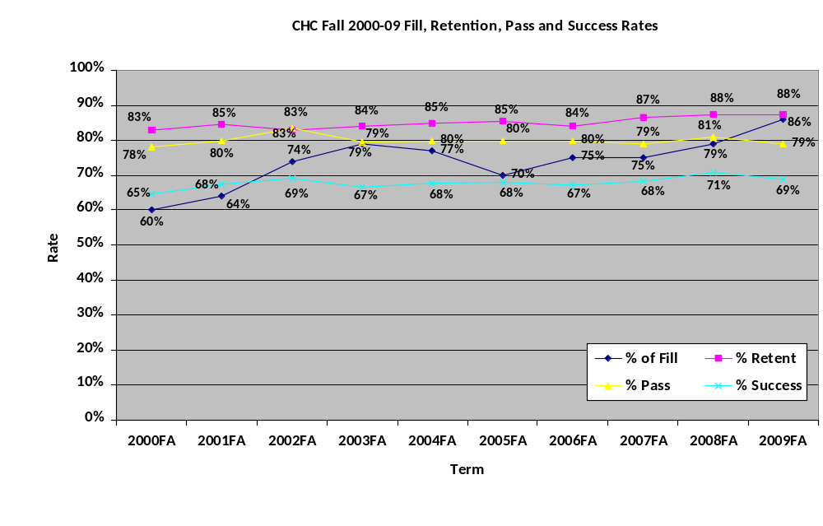
Figure 3.2
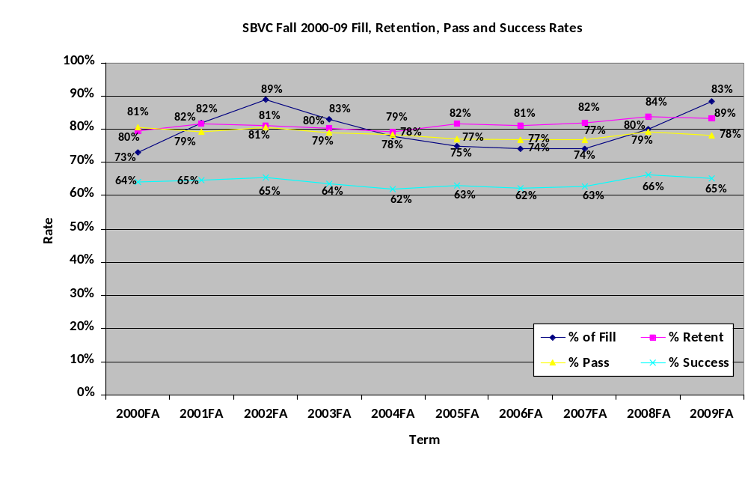
Figure 3.3
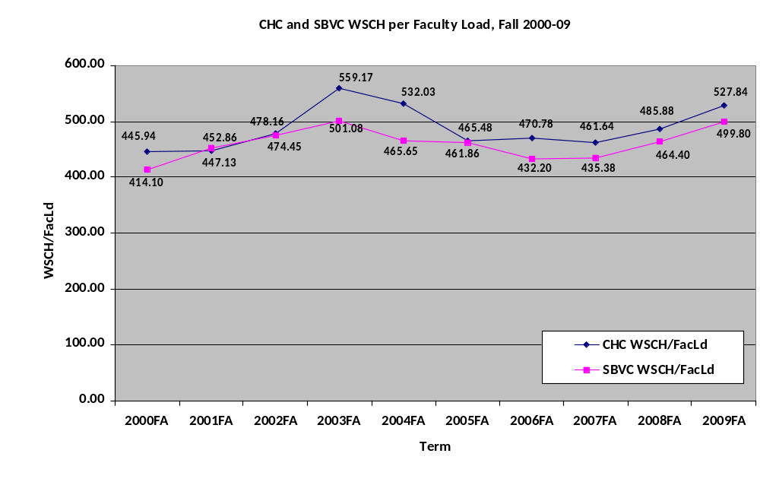
Figure 3.4
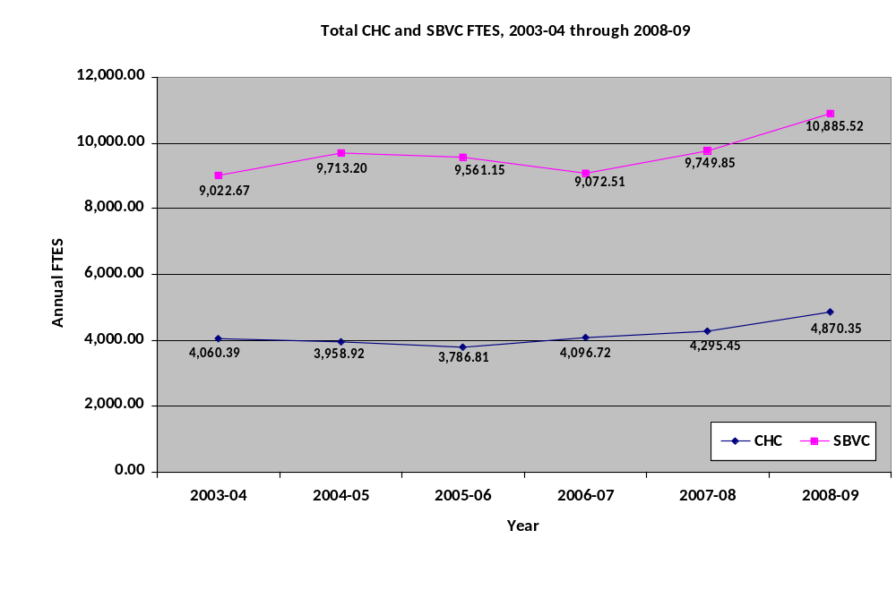

Consolidated Report of Strategic Issues: Highlights and Implications

Highlights

Budget, Law & Regulation, Capital Funding
- The continuing economic slump and large budget shortfalls at the state level provide an uncertain fiscal environment.
- Declining property values erode the tax base, resulting in a possible state funding gap and the inability to sell full value of Measure M construction bonds.
- The Governor proposes suspension of the competitive CalGrant awards program for 2010-11.
- Health care costs continue to rise by double digits.
- The state budget has resulted in limited state revenue bond resources to match local bond dollars for construction projects.
- Major reductions to categorical programs will be compounded by the loss of federal American Recovery and Reinvestment Act (ARRA) funding in 2010-11.
- Funding for workforce development leading to jobs has been proposed.
- The Obama Administration has proposed the American Graduation Initiative (AGI), pending in Congress (H.R. 3221).
- Other important federal legislation—H.R. 4196, The Community College Emergency Fund Stabilization Act and H.R. 2847, The Jobs for Main Street Act of 2010—can provide additional support for community colleges.

Pedagogical Innovations, Accountability and Learning Outcomes
- Accountability and Assessment
  - Continued pressure from WASC, the DOE, and the public for community colleges to demonstrate student learning through assessment and documentation.
  - Challenges related to assessment include philosophical differences among practitioners and assuring validity.
- Alternative Modes of Instruction
  - Strong student demand for online instruction and short-term classes and programs.
  - Availability of technology for instruction (online tools, clickers, smart classrooms, etc.).
- Focus on Clear Pathways
  - Public expectation and need for clear pathways from K-12 to ultimate career goal.
- Active, Student-Centered Teaching and Learning
  - Continued trend towards, and evidence of the effectiveness of, active learning with student involvement.
- Student Success
  - Continued need to help underprepared students succeed in college and gain foundational skills (SCANS, etc.) for success in further education and employment.

Educational Attainment in Relation to Economic Opportunity
- Statewide, the income of three cohorts of wage-earning community college recipients of a degree or certificate (in 2000-01, 2001-02, and 2002-03) were tracked for four years after their awards; none of these students had transferred to a four-year institution. Their median annual income in the first year after the award jumped 39% in 2001, 52% in 2002, and 44% in 2003. By comparison, the California median household income rose 0.6%, 0.7%, and 3.8% in the corresponding years.
- By the fourth year after the award, their median income had risen cumulatively 24%, 29%, and 26% over the first year after the award, respectively. By comparison, the California median household income rose 4%, 1%, and 1% in the corresponding years.
- The year before their award, the median income of these students was 63%, 58%, and 65% of the corresponding California median household income, respectively. By the fourth year, the median income of all three cohorts exceeded the corresponding California median household income.
- Nationally, the unemployment rate in 2007 for people 25 years old and over who had completed only high school was 47% higher than for people who had received only an associate’s degree, and 120% higher than for people who had received a bachelor’s or higher degree.
- Nationally, in 2007, the median annual incomes of full-time workers 25 years old and over by highest level of educational attainment were as follows:
 | High School | Some College | Difference from HS | Associate’s | Difference from HS | Bachelor’s | Difference from HS
Males | $37,860 | $44,900 | 19% | $49,040 | 30% | $62,090 | 64%
Females | $27,240 | $32,840 | 21% | $36,330 | 33% | $45,770 | 68%

Competition for Students
- Real competition for students comes not just from other community colleges, but also from “private educational and training providers capitalizing upon a student’s willingness to commute”—including four-year universities, vocational schools and colleges, liberal arts colleges, institutes of technology, trade schools, and career colleges, all of which may offer degrees or certificates “indistinguishable to the average consumer of higher education” from those offered by SBCCD.
- The following table shows the numbers of various types of private educational institutions within San Bernardino and Riverside Counties that represent potential competition for SBCCD students for at least some courses and/or programs:
Type of Institution | San Bernardino County | Riverside County
Sports and Recreation Instruction | 143 | 165
Fine Art Schools | 88 | 117
Cosmetology and Barber Schools | 31 | 60
Business and Secretarial Schools | 39 | 38
Computer Training | 11 | 15
Flight Training | 14 | 12
Professional and Management Development Training | 14 | 11
Other Technical and Trade Schools | 12 | 6
Language Schools | 2 | 1
TOTALS | 354 | 425
- Including Los Angeles and Orange County institutions in the mix in these categories adds 4,055 competitors, many of which are well within a 60-minute driving radius.

Private Support for Education, Including Grant Opportunities
- Increase opportunities to generate revenue for the Colleges and the District.
  - Increase number of grants for SBCCD.
  - Increase additional external and internal funding opportunities.
    - Private and public support for SBVC and CHC Foundations.
    - Grow partnerships through coordination of employee efforts and the foundation with the community.
    - Create continuing education programs.
    - Consider other income generation activities and nurture existing partnerships.

Technology Issues and Trends Related to Education
- Funding of IT will be a major challenge over the next several years. Institutions will be exploring ways to reduce costs via streamlining operations and technologies, exploring lower cost and/or free technologies (i.e., using free mail services such as gmail or live.edu for email rather than paying for Outlook).
- Institutions will work to consolidate and streamline institutional data through Administrative/Enterprise Resource Planning (ERP) Systems. Such data will include student information, financial services, facilities, human resources, etc.
- Institutions will need to evaluate and decide upon infrastructure technologies (i.e., traditional servers, virtual servers, cloud-based computing, or a combination thereof). Each set of technologies will present its own opportunities and challenges for data security, cost effectiveness, and disaster recovery/continuity of operations.
- Institutions will continue to explore ways to minimize their technology carbon footprint and find ways to conserve energy.
- Social networking will continue to grow as a major means of communication and interaction in learning environments.
- Security of data is in the top 10 list of every major source reviewed. This is attributed to continual movement towards digital recordkeeping; the emerging body of rules, regulations, and laws, etc.; and the liability that inadequate security presents to an institution.
- Identity and access management will be an increasing challenge to ensure privacy and yet ease of access to multiple systems. “Issues surrounding identity/access management include developing strong vetting, credentialing, and provisioning processes for all constituents (including guests), inventorying and integrating decentralized systems into a centralized strategy, and ensuring federation of identity.” (EduCause Review 2009)
- As technology plays an increasingly larger role in teaching and learning, the challenge is to make technology fluid and responsive to faculty instructional needs without impeding the learning process.
- Online learning is projected to continue to grow and learning management systems will be increasingly seen as mission-critical enterprise systems.
- Studies show that online or online-enhanced instruction shows better overall student performance, but studies’ results also indicated that there were too many variables to state so conclusively. Much was dependent on instructional strategies, environment, etc.
- The shift from PCs to mobile devices will continue to be a major trend.

Financial Aid
- The 2010 federal budget builds on ARRA by supporting a $5,550 Pell Grant maximum award in the 2010-2011 school year.
- The Administration will index Pell grants to the Consumer Price Index plus 1 percent in order to address inflation. In addition, the Administration proposes to make the Pell Grant program mandatory, to ensure a regular stream of funding and eliminate the practice of “backfilling” billions of dollars in Pell shortfalls each year.
- Subsidies in the Government-guaranteed student loan program are currently set by the Congress through the political process. The President’s Budget asks the Congress to end the entitlements for financial institutions that lend to students. The Administration will instead take advantage of low-cost and stable sources of capital so students are ensured access to loans, originating all new loans in the direct lending program, saving more than $4 billion a year that is reinvested in aid to students. The Budget also makes campus-based, low-interest loans more widely available through a new modernized Perkins Loan program, overhauling the inefficient and inequitable current Perkins program.
- The Budget includes a new five-year, $2.5 billion Access and Completion Incentive Fund to support innovative State efforts to help low-income students succeed and complete their college education.

District Strategic Planning Implications Identified by the Committee

Budget, Law & Regulation, Capital Funding
- Continued inability to serve all who want to take classes under current model. Over 1,500 unfunded FTES and demand is increasing.
- Possible state funding shortfall due to inability to backfill property taxes.
- Possibility that District will not be able to implement facilities master plan over ten years, due to inability to sell full value of Measure M bonds, due to declining property values.
- Out-of-pocket health care costs for employees jumped this year and cost-containment is difficult with rising health care premiums, which erode salary dollars.
- We may not receive the leverage of matching state funds for capital projects, requiring faster spending of General Bond, Measure M dollars, with fewer projects completing.
- $1 million minimum funding needed to maintain 2008-09 level of support services in categorical programs.
- Need to continually step-up competitive grant writing to obtain workforce development funding to provide alternative instructional experiences for job training and careers.
- & 9. The District needs to become more politically aware and participate in lobbying efforts to support legislation that could have a positive impact on community colleges.

Pedagogical Innovations, Accountability and Learning Outcomes
- Assessment of Student Learning Outcomes will continue to be a “hot topic” in regards to accountability measures. Workloads increase while campuses learn the process and incorporate measurement and continuous improvement as part of their cultures.
- Effective use of technology in the classroom demands frequent upgrades and continuous training for both students and faculty.
- Methods and processes for assuring the quality of online instruction need to be in place.
- Community colleges must partner with K-12, four-year institutions, and employers to develop and maintain clear pathways from education to successful employment. Curriculum needs to be aligned and meaningfully designed to help students succeed in achieving their goals.
- Professional development and support for innovation are both needed for faculty to learn and implement active learning techniques in the classroom. The principles and practices for brain-based learning, learning communities, student engagement, and other best practices need to be shared and implemented.
- Students sometimes feel underprepared and lack some of the crucial skills for success. Colleges must have accurate placement methods, must integrate SCANs skills throughout the curriculum, and continue to align classroom instruction, learning resource centers, and student services.

Educational Attainment in Relation to Economic Opportunity
1. & 2-3. The economic advantages of obtaining a certificate or degree from a California community college are immediate and long-lasting, even for students who do not go on to a four-year institution. These advantages comprise a major selling point for the District in times when it can accommodate growth.
4. Obtaining an AA or AS is insurance against unemployment, another major selling point.
5. Full-time workers with some college, but less than a degree (which included certificates), make one-fifth better money than competitors with only a high school diploma. Full-time workers with an AA or AS make one-third better money than competitors with only a high school diploma. Moving on to a BA or BS only improves income prospects, and the effects of educational attainment are greater for females than for males. These statistics comprise yet another major selling point when the District is seeking growth.

Competition for Students
1. & 2-3. In positioning the Colleges and EDCT with respect to market competitors, in planning for new programs and courses (which of course are intended to attract students), and in considering alternative configurations of existing programs and courses, the District must consider not just neighboring community colleges, but also proprietary institutions within a reasonable commuting distance.

Private Support for Education, Including Grant Opportunities
- External funding—Grants
  - Need for Grant Coordinating Committee under District-wide strategy.
  - Centralize management and grant efforts to avoid competition among Colleges and District for grants and to inform all units better regarding searches and grant opportunities for the benefit of Colleges and the District.
  - Explore hiring grant writers on a contingency basis with expertise in different areas (e.g., capital improvement grants, State Chancellor’s Office) and federal departments (e.g., DOE, NSF).
  - Develop coordination with K-12 and four-year schools for coordinated grant applications.
  - Provide incentives for faculty and others to apply for grants (e.g., writing a winning grant with incentives above base salary).
  - Increase grant writing training and related professional development.
  - Develop projects with internal goals and store until grant opportunities are found that match (use program review lists at District and both Colleges to inform needs for grant opportunities).
  - Create a map/template of data accessible for grant applications.
  - Work with staff to look for and apply for infrastructure grants and coordinate across the District.
  - Need rapid response methods for curricula related to emerging grant solutions.
- Internal and External Funding Opportunities
  - Outreach to community
    - Increase emphasis on alumni.
    - Continual updating of alumni database.
    - Involve KVCR and community development through integrated marketing.
  - Outreach to employees
    - Contributions for short- and long-range estate planning for College benefit.
    - Encourage faculty and staff to participate in community and service organizations representing themselves as well as the District (develop employee guidelines and targeted outreach).
    - Maintain database of employee community and service associations.
    - Offer employee memberships for organizations, which will benefit community development and provide for feedback to Colleges.
  - Create Continuing Education opportunities
    - Conduct fee-based classes at night on campus.
    - Develop programs for tuition students to earn certificates.
    - Business/finance/entrepreneurship, grant writing training, “green,” etc.
  - Other income generation ideas
    - Renting facilities.
    - Increase use of Sunroom by inviting community to restaurant-test project.
    - Develop plan for foundation to become self-supporting.

Technology Issues and Trends Related to Education
- Money will drive what technology looks like over the next several years.
- If ERPs are pursued, our District will be positioned well to have relatively fast and easy access to data that can improve our decision-making.
- Faculty/students/departments/clubs/etc. will be interacting more and more via social networking and other free-source methods. Our District will need to anticipate and accommodate such changes in our planning, procedures, policies, training, etc.
- Data integrity and security need to stay at the forefront of concerns for our District and should be considered with every technology procurement, and every modification or development of policy, procedure, or plan.
- Communication and collegial consultation are key to navigating the challenges of fiscal cuts yet providing meaningful technology services and access to faculty.
- As new technologies are explored, compatibility with multiple user devices, rather than just traditional computers, needs to be considered.

Major Planning Assumptions

The following major planning assumptions are based upon an analysis of the Strategic Issues Subcommittee Reports, the performance and impact indicators, the Center of Excellence Environmental Scan reports, and the Committee’s discussions of all these items (and more) as set forth in the Edited Transcripts of Posted Comments and the Minutes.

- Everything the District does should contribute directly or indirectly to the facilitation of student learning.
- Accrediting agencies, governmental agencies, and the public will continued to exert pressure on community colleges to demonstrate successful student learning through assessment and documentation.
- Student demand for alternative modes and schedules of instruction and services, especially those mediated by technology, will continue to rise.
- Coordination among the segments of education aimed at clearing student pathways through the system will be increasingly necessary.
- Curricular, pedagogical, and service innovations will be necessary to keep up with the increasingly complex needs of students, to attract them to District institutions, and to respond to the changing communities that the District serves.
- Professional development in numerous subjects for all employees will be increasingly crucial to success in serving students.
- The District’s budget will continue to be under pressure for at least the next few years, because of uncertainty in the State’s fiscal environment, rising healthcare and other costs, limitations on State revenue bond resources, the loss of federal stimulus funds, the loss of categorical funds, and other factors.
- Systematic development of alternative sources of revenue will be necessary to provide greater stability in funding District programs and services.
- Demand for community college classes will remain high, and we will not be able to serve all the students who wish to take them.
- Competition for these students will rise, and the District will have to market the low costs and substantial benefits of attending its colleges actively, to avoid ceding the field to competitors.
- Funding for capital projects will remain uncertain, so that some planned projects might not be completed.
- Integrity and security of data will continue to rise in importance.
- Integrating institutional data systems, maintaining and improving technological infrastructure, keeping up with shifts in computing and communication modes, and funding technology will remain challenging for the foreseeable future.

A Brief Introduction to Planning Terminology

The conceptual boundaries among strategic directions, goals, objectives, and actions are often vague: An objective under one initiative might be a goal under another, for example. The following is intended as a rough guide to understanding these terms as used in this District Strategic Plan, not a set of hard-and-fast rules.
Strategic Direction
Definition: An essential line of forward progress along which the institution seeks to move in the long run, and with which it seeks to align its resources and actions, to realize more fully its mission.
Characteristics of a Sound Strategic Direction
- Establishes the Big Picture, in concert with other Strategic Directions
- Serves to guide the planning and decision-making of the institution as a whole
- Well-defined subsidiary goals and objectives are required for effective pursuit of each Strategic Direction.
- Very long-range and stable over time (typically more than five years)
Example: Learning-Centered Institution for Student Access, Retention, and Success
Goal
Definition: A major aspiration that the institution intends to realize under a given Strategic Direction.
Characteristics of a Sound Goal
- Reflects the Big Picture
- Clearly serves the interests of the institution as a whole
- Ambitious—even audacious!—yet attainable in principle
- Achievement of the Goal represents significant progress in the applicable Strategic Direction.
- Relatively long-range and stable over time (typically three to five years), until it is achieved
- Shows applicable linkages to other planning structures or documents
Example: Improve student retention, success, and persistence across the District.
Objective
Definition: A concrete, measurable milestone on the way to achieving a Goal.
Characteristics of a Sound Objective
- Relevant and significant with respect to the applicable Goal
- Brings the Goal down to earth in clear language
- Achievement of the objective represents significant progress toward achievement of that Goal.
- Achievement of all the objectives related to a Goal does not necessarily mean achievement of that Goal; it often represents completion of one phase of work that will continue with the formulation of additional objectives and action plans.
- Achievable in typically one to two years
- Shows the tentative timeline or deadline for completion of the objective
- Shows the specific point person or group with overall responsibility for ensuring that progress on the objective occurs as planned
- May show estimated resources required for achievement
- Specific
- Measurable: Shows measures or sources of data for progress measurements, whether quantitative, qualitative, or both
- Reasonable
  - Scope
  - Timeline or Deadline
- Lends itself to formulation of a coherent set of Actions
Example: Provide financial and technological support for the improvement of classroom instruction and student support services.
Action
Definition: One of a coherent set of specific steps that must be taken to reach the objective.
Characteristics of a Sound Action
- Specific
- Reasonable
  - Scope
  - Timeline (typically one year or less)
  - Workloads
- Completion of all the activities under an objective typically means achievement of that objective.
Example: Offer teaching and learning symposiums for interested faculty, students, and others.

Overview of Strategic Directions, Goals, and Alignment with College Plans

District Strategic Directions | District Strategic Goals | Aligned College Goals
1. Institutional Effectiveness  (Board Imperative I) | 1.1 Implement and integrate decision-making, planning, and resource allocation structures and processes that are collaborative, transparent, evidence-based, effective, and efficient. | Crafton Hills College  6.1 Implement and integrate planning processes and decision-making that are: Collaborative, Transparent, Evidence-based, Effective, and Efficient.  6.2 Establish and document effective, efficient, and consistent organizational structures and processes.  San Bernardino Valley College  3.1 Integrate budget, planning, and decision-making: Budget and Planning processes are integrated, relating to the College’s Mission and Strategic Goals.
2. Learning Centered Institution for Student Access, Retention and Success  (Board Imperative II) | 2.1 Ensure access to and delivery of programs, services, and support that meet the diverse needs of students, prospective students, and the community.  2.2 Improve student retention, success, and persistence across the District.  2.3 Achieve excellence in teaching and learning at all District sites through professional development and a continuous improvement process. | Crafton Hills College  1.1 Support, guide, and empower every student to achieve his or her goals.  1.2 Deliver and ensure access to programs, services, and support that meet students’ needs.  3.1 Achieve college-wide excellence in teaching and learning through best practices and ongoing reflection, assessment, and improvement.  San Bernardino Valley College  1.1 Coordinate access efforts for potential students: A systematic, integrated program will be developed to assist student access to SBVC resources and services.  1.2 Increase the percentage of HS graduating seniors who apply and enroll at SBVC: SBVC will serve greater numbers of graduating high school seniors.  1.3 Ensure that prospective and enrolled students have access to support services: SBVC will provide integrated resources and services to students.  5.1 Foster a learning college: Student learning outcomes and assessments for all courses and programs are complete and operational. Core competencies are completed college wide.  5.2 Increase student persistence and retention (ARCC): There will be an increase in the number of students who complete Certificate and Degree programs.
3. Resource Management for Efficiency, Effectiveness and Excellence  (Board Imperative III) | 3.1 Optimize the development, maintenance, and use of resources in accord with applicable plans.  3.2 Provide technology that supports excellence in teaching, learning, and support.  3.3 Effectively manage enrollment across the District through a dynamic balance of identified needs and available resources. | Crafton Hills College  4.1 Effectively manage enrollment through a dynamic balance of identified needs and available resources.  4.2 Identify and initiate the development of new courses and programs that align strategically with the needs of the College and its students.  7.1 Optimize the organization’s human resource capacity.  8.1 Maintain and use resources effectively.  8.2 Seek, advocate for, and acquire additional resources.  8.3 Maximize resource capacity related to facilities, technology, and other infrastructure.  San Bernardino Valley College  6.1 Provide state-of-the-art technology in its teaching and learning environment and service areas: Students will be provided appropriate opportunities to learn utilizing current and available technologies.  6.2 Provide a method for leadership and support of campus technology: A centralized structure for providing campus technology and support will be in place.
4. Enhanced and Informed Governance and Leadership  (Board Imperative IV) | 4.1 Optimize governance structures and processes throughout the District.  4.2 Continuously develop leaders among all groups. | Crafton Hills College  7.2 Manage change proactively.
5. Inclusive Climate | 5.1 Value diversity and promote inclusiveness among employees, students, and the community. | Crafton Hills College  2.1 Seek, welcome, and respect diversity, and promote inclusiveness.  San Bernardino Valley College  2.2 SBVC is an institution that is respectful and accepting of staff and student differences: SBVC will have developed and implemented ongoing programs to maintain a high level of interaction with, and appreciation of SBVC’s diverse populations.
6. Community Collaboration and Value | 6.1 Enhance the District’s value and image in the communities.  6.2 Forge partnerships with other academic institutions, governmental agencies, and private industry to support the District’s and Colleges’ missions. | Crafton Hills College  5.1 Enhance the College’s value to the community.  San Bernardino Valley College  2.1 Enhance the image of the college: SBVC will be recognized for its excellent reputation and as an inviting place to work and study.  4.1 Forge and support dynamic partnerships with other academic institutions, governmental agencies and private industry: SBVC has external partners and integrates these relationships into planning and program development.

District Strategic Directions, Goals, and Objectives

Strategic Direction 1
Institutional Effectiveness
(Board Imperative I)
Goal 1.1: Implement and integrate decision-making, planning, and resource allocation structures and processes that are collaborative, transparent, evidence-based, effective, and efficient.

Objective | 1.1.1: Create structures and processes to ensure effective communication about decision-making and collegial consultation among all District entities (namely, CHC, SBVC, DETS, EDCT, KVCR, and District Office).
Suggested Actions | Publish a periodic Chancellor’s Chat, summarizing significant developments and decisions during each month and including other useful information as needed.  At the end of each annual budget cycle, make readily available to all employees the final decisions and rationales on all resource requests.  Train all collegial-consultation committee members in their responsibilities (e.g., participating actively, informing and soliciting feedback from constituents), and in how the committees function.
Tentative Timeline/Deadline for Objective | 2010-11
Point Person or Group for Objective | Chancellor’s Cabinet
Measurements of Progress | Survey of constituency groups and individuals  Outcome: X% satisfaction with effectiveness of communication  Chancellor’s Chat contents  Resource request list decisions and rationales  Number of training sessions and participants  Training session evaluations

Objective | 1.1.2: Facilitate collaboration, cooperation, and coordination across the District.
Suggested Actions | Coordinate periodic joint meetings of analogous governance and other bodies from both Colleges (e.g., College Councils, Curriculum Committees).  Train District employees in problem-solving methods and strategies (e.g., workshops on interest-based problem-solving).
Tentative Timeline/Deadline for Objective | 2010-12 and ongoing
Point Person or Group for Objective | College Presidents
Measurements of Progress | Documentation of meetings  Surveys of applicable groups and individuals

Strategic Direction 2
Learning Centered Institution for Student Access, Retention and Success
(Board Imperative II)
Goal 2.1: Ensure access to and delivery of programs, services, and support that meet the diverse needs of students, prospective students, and the community.

Objective | 2.1.1: Provide financial and technological support for the facilitation of student access to programs and services.
Suggested Actions | Audit existing practices related to student access to programs and services.  Evaluate student and staff satisfaction regarding access to programs and services, and implement improvements based on results.  Facilitate collaboration and problem-solving between colleges regarding methods for student access.  Explore innovative and effective practices and technologies related to student access.  Experiment with pilot programs based on the results of the exploration.  Evaluate the pilot programs.  Implement effective practices based on the evaluation.  Identify and evaluate potential external sources of funding for these activities.  Resources: Provide adequate funding and other support for these activities.
Tentative Timeline/Deadline for Objective | 2010-12 and ongoing
Point Person or Group for Objective | Vice Chancellor, Fiscal Services  Executive Director, DETS
Measurements of Progress | Audit results  Assess survey results  Documentation of collaboration on methods  Report on results of exploration  Pilot program descriptions  Pilot program evaluation results  Documentation of resources provided

Goal 2.2: Improve student retention, success, and persistence across the District.

Objective | 2.2.1: Provide financial and technological support for the improvement of classroom instruction and student support services.
Suggested Actions | Allow time for discipline-specific professional collaboration during in-service days (e.g., technology in the classroom, teaching methods).  Offer teaching and learning symposiums for interested faculty, students, and others.  Explore the effective use of technology related to instruction and classroom management.  Identify pressing College needs for technology in the classroom, and facilitate implementation of technology that meets them.  Provide effective training in these technologies.  Identify and evaluate potential external sources of funding for these activities.  Resources: Provide adequate funding and other support for these activities.
Tentative Timeline/Deadline for Objective | 2010-11 and ongoing
Point Person or Group for Objective | VPIs  Executive Director, DETS
Measurements of Progress | In-service day schedules  Symposia outlines, attendance figures, and evaluation results  Number of grants sought and received, with dollar amounts  Documentation of needs  Documentation of implementation and match with needs  Number of training sessions and participants  Training session evaluations  Documentation of resources provided

Objective | 2.2.2: Develop and implement a District Staffing Plan that includes targets for improvement of full-time/part-time faculty ratios.
Suggested Actions | Conduct research to determine appropriate targets that will promote steady improvement and timelines that are flexible enough to accommodate a range of budgetary constraints. (ML)  Adopt appropriate targets.  Finalize the District Staffing Plan.
Tentative Timeline/Deadline for Objective | 2011-12 and ongoing
Point Person or Group for Objective | Vice Chancellor, Human Resources
Measurements of Progress | Approved Staffing Plan with applicable targets  Annual report of FT/PT faculty ratio

Goal 2.3: Achieve excellence in teaching and learning at all District sites through professional development and a continuous improvement process.

Objective | 2.3.1: Maintain District commitment to professional development at the Colleges. [See also 3.1.1 and 4.2.1.]
Suggested Actions | Establish a coordinating body to ensure an efficient, equitable, robust professional development program. (Originally proposed as an objective under 4.2)  Reinstitute the sabbatical.  Establish a central repository for best practices in education.  Conduct an annual survey of employees on professional development opportunities and effectiveness.  Resources: Provide adequate funding and other support for these activities.
Tentative Timeline/Deadline for Objective | 2010-12 and ongoing
Point Person or Group for Objective | Professional Development Committee chairs
Measurements of Progress | Documentation of attendance of staff and faculty at professional development activities, including those held at District sites other than their own  Survey results

Objective | 2.3.2: Maintain the district commitment to continuous improvement processes.
Suggested Actions | Provide adequate training of faculty and staff in appropriate and pertinent accreditation standards and processes.  Provide adequate training of faculty and staff in the continuous cycle of evaluation and improvement of programs, Student Learning Outcomes, and Service Area Outcomes  Resources: Provide adequate funding, facilities, technology, staffing, and other support for these activities.
Tentative Timeline/Deadline for Objective | 2010-11 and ongoing
Point Person or Group for Objective | Chancellor’s Cabinet
Measurements of Progress | Number of training sessions and participants  Training session evaluations  Documentation of resources provided

Strategic Direction 3
Resource Management for Efficiency, Effectiveness and Excellence
(Board Imperative III)
Goal 3.1: Optimize the development, maintenance, and use of resources in accord with applicable plans.

Objective | 3.1.1: Evaluate and enhance the system for training employees in accordance with District plans. [See also 2.3.1 and 4.2.1.]
Suggested Actions | Identify training needs.  Develop appropriate training programs to meet the needs.  Deliver training to employees.  Evaluate the program annually and revise it as needed.
Tentative Timeline/Deadline for Objective | Fall 2011
Point Person or Group for Objective | Vice Chancellor, Human Resources  Professional Development Committee chairs
Measurements of Progress | Number of training sessions and participants  Training session evaluations  Documentation of training contents and modes

Objective | 3.1.2: Develop processes that support the transparent allocation of resources District-wide.
Suggested Actions | Finalize resource allocation model and process.  District Budget Committee evaluates the process annually and recommends improvements as needed.
Tentative Timeline/Deadline for Objective | Spring 2010
Point Person or Group for Objective | Vice Chancellor, Fiscal Services
Measurements of Progress | Adopted District-wide resource allocation process.

Goal 3.2: Provide technology that supports excellence in teaching, learning, and support.

Objective | 3.2.1: Finalize overall organizational structure for the delivery of identified technology services.
Suggested Actions | Annually review the respective roles of the District and campus technology departments.  Publish the organizational structure for technology services.  Publish a master list of District-supported software and systems.
Tentative Timeline/Deadline for Objective | Spring 2010
Point Person or Group for Objective | Executive Director, DETS
Measurements of Progress | Documentation of final approved structure  Publication of catalog of services

Goal 3.3: Effectively manage enrollment across the District through a dynamic balance of identified needs and available resources.

Objective | 3.3.1: Integrate and coordinate campus-level enrollment management with District resource allocation processes.
Suggested Actions | Determine resources available to Colleges.  Colleges develop enrollment management plans to match available resources.  Colleges review and modify enrollment management plans based in part on accuracy of enrollment projections.
Tentative Timeline/Deadline for Objective | Spring 2011
Point Person or Group for Objective | College Presidents  Vice Chancellor, Fiscal Services
Measurements of Progress | Annual report of enrollment data  Annual evaluation of accuracy of enrollment projections

Strategic Direction 4
Enhanced and Informed Governance and Leadership
(Board Imperative IV)
Goal 4.1: Optimize governance structures and processes throughout the District.

Objective | 4.1.1: Periodically evaluate, enhance, and document District collegial-consultation structures and processes.
Suggested Actions | Evaluate the charges of all District collegial-consultation bodies annually, and revise them as needed.  Evaluate the effectiveness of District collegial-consultation bodies, and implement improvements based on results.  Develop and disseminate a template for committees to use in reporting back to constituency groups.
Tentative Timeline/Deadline for Objective | 2010-11
Point Person or Group for Objective | Chancellor
Measurements of Progress | Documentation of the charges of the governance bodies  Satisfaction with effectiveness of District governance bodies

Objective | 4.1.2: Periodically evaluate, enhance, and document the functional relationships among District entities.
Suggested Actions | Create a map of the functional relationships among District entities.  Evaluate the effectiveness of the functional relationships, and implement improvements based on results.
Tentative Timeline/Deadline for Objective | 2010-11
Point Person or Group for Objective | Chancellor’s Cabinet
Measurements of Progress | Approved map of functional relationships  Satisfaction with effectiveness of functional relationships

Goal 4.2: Continuously develop leaders among all groups.

Objective | 4.2.1: Facilitate the development of leaders through professional development. [See also 2.3.1 and 3.1.1.]
Suggested Actions | Establish a regular cycle of comprehensive leadership training experiences.  Evaluate each experience and modify the offerings as needed.
Tentative Timeline/Deadline for Objective | 2010-11 and ongoing
Point Person or Group for Objective | Professional Development Committee chairs
Measurements of Progress | Comprehensive schedule of events  Number of training sessions and participants  Training session evaluations

Strategic Direction 5
Inclusive Climate
Goal 5.1: Value diversity and promote inclusiveness among employees, students, and the community.

Objective | 5.1.1: Establish a District mentoring program for all new employees.
Suggested Actions | Develop mentoring program.  Designate a person at each site to connect mentors with mentees.  Evaluate program, and implement changes based on results of evaluation.
Tentative Timeline/Deadline for Objective | Fall 2011
Point Person or Group for Objective | Vice Chancellor, Human Resources
Measurements of Progress | Documentation of program  Surveys of mentors, mentees, and others on program effectiveness

Objective | 5.1.2: Coordinate District-wide events celebrating diversity for students, employees, and the community.
Suggested Actions | Work collaboratively with representative groups from CHC, SBVC, and District offices to develop events.  Create and disseminate effectively a District-wide calendar of events celebrating diversity.
Tentative Timeline/Deadline for Objective | 2010-11
Point Person or Group for Objective | College Presidents
Measurements of Progress | Schedule of events  Evaluation of events’ effectiveness

Strategic Direction 6
Community Collaboration and Value
Goal 6.1: Enhance the District’s value and image in the communities.

Objective | 6.1.1: Develop a comprehensive District marketing and outreach plan, coordinated with those of the Colleges, to raise the communities’ awareness of education and training services.
Suggested Actions | Establish the committee.  Conduct a community audit or survey.  Develop the plan.  Implement the plan.  Evaluate the effectiveness of the plan, and revise it as needed.  Develop a Message Deck to ensure consistency in District communications to the public.
Tentative Timeline/Deadline for Objective | Spring 2011-Fall 2011
Point Person or Group for Objective | Marketing Committee composed of representatives from each entity, including KVCR and EDCT
Measurements of Progress | Documentation of committee establishment and meetings  Documentation of the plan  Media standards  Pattern of expenditures for outreach, advertising, etc.

Goal 6.2: Forge partnerships with other academic institutions, governmental agencies, and private industry to support the District’s and Colleges’ missions.

Objective | 6.2.1: Establish a high-level Community Leaders Roundtable.
Suggested Actions | Establish the purposes of the group.  List appropriate candidates for membership and solicit their interest.  Establish the group.  Meet at least twice annually and document the proceedings.
Tentative Timeline/Deadline for Objective | Spring 2011
Point Person or Group for Objective | Chancellor’s Cabinet
Measurements of Progress | Documentation of group establishment and meetings  Documentation of BAR recommendations and other actions

Objective | 6.2.2: Establish a Community Affinity Network to promote and document productive relationships between District employees and organizations in the surrounding communities.
Suggested Actions | Create an online social media discussion area to help maximize use of and access to community resources.  Create and disseminate annually a list of program sponsors, including Advisory Committee members.  Create and maintain a District-wide calendar of the use of facilities for activities.
Tentative Timeline/Deadline for Objective | Fall 2011-Spring 2013
Point Person or Group for Objective | Chancellor’s Cabinet
Measurements of Progress | Documentation of discussion area content and usage  Published list of program sponsors  Published calendar of facilities use

Objective | 6.2.3: Support and strengthen Career Pathways.
Suggested Actions | Promote collaboration among the District entities and with K-12, four-year institutions, and the business community regarding Career Pathways.
Tentative Timeline/Deadline for Objective | 2011-12
Point Person or Group for Objective | VPIs
Measurements of Progress | Documentation of the outcomes of collaboration

Long-Range Financial Plan and Forecast

To assist the Colleges in planning for long-term resource allocations, Fiscal Services updates the following Long-Range Financial Plan and Forecast annually. It is based in part on the District Resource Allocation Model approved in Spring 2010, and applies only to the General Fund, the primary operating fund of the District and Colleges.

Scenarios A and B represent a range of assumptions from conservative to optimistic. Neither, however, accounts for yearly budget interventions, significant changes in college services, or other District/College changes. Moreover, it is important to note that since final decisions on filling SERP and 2009-10 vacancies have not been made as of publication of this Plan, none of the projected scenarios includes expenditures for filling any of those vacancies. See Revenue, Expenditure, and Other Forecast Assumptions below for factors that are taken into consideration.

Scenario A illustrates a "conservative" projection of revenues, assessments, and expenditures. Line items resulting from State allocations such as FTES Credit and Noncredit Funding rates, Growth allocations, COLA, PT Faculty, and Lottery Funds are assumed with 0% increases. Other line items such as Interest Income and Other Campus Revenues are also assumed with 0% increases. This scenario assumes marginal increases in District assessments and College expenditures.

Scenario B illustrates an "optimistic" projection of revenues, assessments, and expenditures. Line items resulting from all allocations including FTES Credit and Noncredit Funding rates, Growth allocations, COLA, PT Faculty, Lottery Funds, Interest Income, and Other Campus Revenues are assumed with varying percent increases based on historical trends. This scenario assumes moderate increases in District assessments and College expenditures.

The figures in both scenarios are for illustrative purposes only, since District 2010-11 budget numbers as of publication of this Plan are not yet final.
Forecast, 2010-11 through 2012-13

 |  | 2010-11 |  | 2011-12 |  | 2012-13
 |  | Scenario A | Scenario B | Scenario A | Scenario B | Scenario A | Scenario B
Beginning Fund Balance |  | $0 | $0 | ($2,690,502) | $25,996 | ($6,045,968) | $919,783
Revenues
 | Base Funding Rate: Total FTES <=10,000 for Multi-College District | $3,321,545 | $3,387,976 | $3,321,545 | $3,455,735 | $3,321,545 | $3,524,850
 | Base Funding Rate: Total FTES >=10,000 for Multi-College District | $3,875,136 | $3,952,639 | $3,875,136 | $4,031,691 | $3,875,136 | $4,112,325
 | Total Credit FTES Funding | $62,841,458 | $64,739,270 | $62,841,458 | $66,694,396 | $62,841,458 | $68,708,567
 | Total Noncredit FTES Funding | $30,661 | $31,587 | $30,661 | $32,541 | $30,661 | $33,524
 | Growth | $0 | $681,588 | $0 | $701,827 | $0 | $722,669
 | Cost of Living Adjustment (COLA) | ($266,261) | ($274,024) | $0 | $1,484,287 | $0 | $1,527,585
 | Part-time Faculty | $192,987 | $192,987 | $192,987 | $192,987 | $192,987 | $192,987
 | Lottery Funds | $1,411,223 | $1,411,223 | $1,411,223 | $1,411,223 | $1,411,223 | $1,411,223
 | Interest Income | $376,780 | $376,780 | $376,780 | $376,780 | $376,780 | $376,780
 | Other Campus Revenue | $678,086 | $678,086 | $678,086 | $678,086 | $678,086 | $678,086
Total Revenues |  | $72,461,615 | $75,178,113 | $72,727,877 | $79,059,554 | $72,727,877 | $81,288,597
Expenditures
 | Academic Salaries | $32,265,643 | $32,265,643 | $32,749,628 | $33,394,941 | $33,240,872 | $34,563,763
 | Classified Salaries | $17,331,411 | $17,331,411 | $17,591,382 | $17,938,010 | $17,855,253 | $18,565,841
 | Benefits | $12,484,673 | $12,484,673 | $12,671,943 | $13,108,907 | $12,862,022 | $13,764,352
 | Supplies | $1,764,023 | $1,764,023 | $1,764,023 | $1,852,224 | $1,764,023 | $1,944,835
 | Contracts and Services | $10,572,454 | $10,572,454 | $10,572,454 | $11,101,077 | $10,572,454 | $11,656,131
 | Capital Outlay | $733,913 | $733,913 | $733,913 | $770,609 | $733,913 | $809,139
 | Other Outgoing | $0 | $0 | $0 | $0 | $0 | $0
Total Expenditures |  | $75,152,117 | $75,152,117 | $76,083,343 | $78,165,767 | $77,028,537 | $81,304,061
Operating Surplus/(Deficit) |  | ($2,690,502) | $25,996 | ($3,355,466) | $893,787 | ($4,300,661) | ($15,464)
Ending Fund Balance |  | $0 | $0 | ($6,045,968) | $919,783 | ($10,346,629) | $904,319
Revenue, Expenditure, and Other Forecast Assumptions

 |  | 2010-11 |  | 2011-12 |  | 2012-13
Revenue Assumptions |  | Scenario A | Scenario B | Scenario A | Scenario B | Scenario A | Scenario B
 | Base Funding Rate Increase | 0.00% | 2.00% | 0.00% | 2.00% | 0.00% | 2.00%
 | Base Funding Increase (Per Credit FTES) | 0.00% | 2.00% | 0.00% | 2.00% | 0.00% | 2.00%
 | Base Funding Increase (Per Noncredit FTES) | 0.00% | 2.00% | 0.00% | 2.00% | 0.00% | 2.00%
 | Constrained Growth (%) | 0.00% | 1.00% | 0.00% | 1.00% | 0.00% | 1.00%
 | Cost of Living Adjustment (COLA %) | -0.38% | -0.38% | 0.00% | 2.00% | 0.00% | 2.00%
 | Part-time Faculty Increase | 0.00% | 0.00% | 0.00% | 0.00% | 0.00% | 0.00%
 | Lottery Funds Increase | 0.00% | 0.00% | 0.00% | 0.00% | 0.00% | 0.00%
 | Interest Income Increase | 0.00% | 0.00% | 0.00% | 0.00% | 0.00% | 0.00%
 | SBVC Other Campus Revenue Increase | 0.00% | 0.00% | 0.00% | 0.00% | 0.00% | 0.00%
 | CHC Other Campus Revenue Increase | 0.00% | 0.00% | 0.00% | 0.00% | 0.00% | 0.00%
 | District Office Services Assessment Increase | 0.00% | 0.00% | 1.50% | 4.00% | 1.50% | 4.00%
 | District-wide Costs Assessment Increase | 0.00% | 0.00% | 1.50% | 4.00% | 1.50% | 4.00%
 | Auxiliary Operations Assessment Increase | 0.00% | 0.00% | 1.50% | 4.00% | 1.50% | 4.00%
 | SERP Costs Assessment Increase | 0.00% | 0.00% | 0.00% | 0.00% | 0.00% | 0.00%
 | District Reserves Assessment Increase | 0.00% | 0.00% | 0.00% | 0.00% | 0.00% | 0.00%
Expenditure Assumptions
 | Academic and Classified Step and Column Increases | Included | Included | 1.50% | 1.50% | 1.50% | 1.50%
 | Academic and Classified Salaries COLA Increases | -0.38% | -0.38% | 0.00% | 2.00% | 0.00% | 2.00%
 | Benefits Increases | Included | Included | 1.50% | 5.00% | 1.50% | 5.00%
 | Supplies Increases | Included | Included | 0.00% | 5.00% | 0.00% | 5.00%
 | Contracts and Services Increases | Included | Included | 0.00% | 5.00% | 0.00% | 5.00%
 | Capital Outlay Increases | Included | Included | 0.00% | 5.00% | 0.00% | 5.00%
 | Other Outgo Increases | Included | Included | 0.00% | 0.00% | 0.00% | 0.00%
Other Assumptions
 | SBVC Total Funded FTES (% of Total) | 70.00% | 70.00% | 70.00% | 70.00% | 70.00% | 70.00%
 | CHC Total Funded FTES (% of Total) | 30.00% | 30.00% | 30.00% | 30.00% | 30.00% | 30.00%
 | Academic and Classified Salaries COLA may differ from State COLA

Characteristics of the Colleges

District Strategic Planning Implications Identified by the Committee

The DSPC discussed student demographics of both Colleges in light of the environmental scan information (see page 47), and identified the following main implications for District strategic planning:

- All District planning and resource allocation should be aware of the differences between the Colleges in ethnicity, age, socioeconomic status, urban environment, and other factors.
- The Colleges should consider the following coordinated efforts:
  - Partnering and integration on workforce development issues/programs.
  - Integration and coordination of early college awareness.
  - Integration of professional development activities.
  - Integration and coordination of outreach to growing/diverse populations.
  - Resource sharing.
- The Colleges should continue to employ multiple delivery methods for programs and services.

Student Demographics: Crafton Hills College

Table 10.1: Number and Percent of CHC Students by Gender and Academic Year from 2006-07 to 2008-09
Gender | Academic Year
Gender | 2006-07 |  | 2007-08 |  | 2008-09
Gender | # | % | # | % | # | %
Female | 4,233 | 48.0 | 4,528 | 48.8 | 4,825 | 50.7
Male | 4,436 | 50.3 | 4,615 | 49.7 | 4,600 | 48.3
Unknown | 143 | 1.6 | 142 | 1.5 | 92 | 1.0
Total | 8,812 | 100.0 | 9,285 | 100.0 | 9,517 | 100.0

Table 10.2: Number and Percent of CHC Students by Ethnicity and Academic Year from 2006-07 to 2008-09
Ethnicity | Academic Year
Ethnicity | 2006-07 |  | 2007-08 |  | 2008-09
Ethnicity | # | % | # | % | # | %
Asian | 495 | 5.6 | 498 | 5.4 | 554 | 5.8
African American | 371 | 4.2 | 373 | 4.0 | 442 | 4.6
Hispanic | 2,160 | 24.5 | 2,337 | 25.2 | 2,455 | 25.8
Native American | 118 | 1.3 | 133 | 1.4 | 104 | 1.1
Pacific Islander | 40 | 0.5 | 56 | 0.6 | 53 | 0.6
White | 4,966 | 56.4 | 5,217 | 56.2 | 5,113 | 53.7
Unknown | 662 | 7.5 | 671 | 7.2 | 796 | 8.4
Total | 8,812 | 100.0 | 9,285 | 100.0 | 9,517 | 100.0

Table 10.3: Number and Percent of CHC Students by Age and Academic Year from 2006-07 to 2008-09
Age | Academic Year
Age | 2006-07 |  | 2007-08 |  | 2008-09
Age | # | % | # | % | # | %
19 or younger | 2,413 | 27.4 | 2,550 | 27.5 | 2,723 | 28.6
20-24 | 2,694 | 30.6 | 2,946 | 31.7 | 3,189 | 33.5
25-29 | 1,194 | 13.5 | 1,231 | 13.3 | 1,267 | 13.3
30-34 | 655 | 7.4 | 700 | 7.5 | 671 | 7.1
35-39 | 548 | 6.2 | 545 | 5.9 | 510 | 5.4
40-49 | 821 | 9.3 | 838 | 9.0 | 723 | 7.6
50 and above | 453 | 5.1 | 457 | 4.9 | 429 | 4.5
Unknown | 34 | 0.4 | 18 | 0.2 | 5 | 0.1
Total | 8,812 | 100.0 | 9,285 | 100.0 | 9,517 | 100.0

Table 10.4: Number and Percent of CHC Students by Disability Status and Academic Year
from 2006-07 to 2008-09
Disability Status | Academic Year
Disability Status | 2006-07 |  | 2007-08 |  | 2008-09
Disability Status | # | % | # | % | # | %
Not a Disability | 8,465 | 96.1 | 8,929 | 96.2 | 9,146 | 96.1
Disability | 347 | 3.9 | 356 | 3.8 | 371 | 3.9
Total | 8,812 | 100.0 | 9,285 | 100.0 | 9,517 | 100.0
Note: Students identified as having a disability received services from the Disabled Students Programs and Services (DSP&S) in the respective academic year. Students not identified as receiving services from DSP&S might have had a disability that was not identified by the college.

Student Demographics: San Bernardino Valley College

Table 10.5: Number and Percent of SBVC Students by Gender and Academic Year from 2006-07 to 2008-09
Gender | Academic Year
Gender | 2006-07 |  | 2007-08 |  | 2008-09
Gender | # | % | # | % | # | %
Female | 10,980 | 56.0 | 11,539 | 55.5 | 12,321 | 55.6
Male | 8,497 | 43.4 | 9,142 | 44.0 | 9,719 | 43.9
Unknown | 121 | 0.6 | 107 | 0.5 | 123 | 0.6
Total | 19,598 | 100.0 | 20,788 | 100.0 | 22,163 | 100.0

Table 10.6: Number and Percent of SBVC Students by Ethnicity and Academic Year from 2006-07 to 2008-09
Ethnicity | Academic Year
Ethnicity | 2006-07 |  | 2007-08 |  | 2008-09
Ethnicity | # | % | # | % | # | %
Asian | 1,219 | 6.2 | 1,344 | 6.5 | 1,427 | 6.4
African American | 3,957 | 20.2 | 4,127 | 19.9 | 4,291 | 19.4
Hispanic | 8,076 | 41.2 | 8,784 | 42.3 | 9,741 | 44.0
Native American | 187 | 1.0 | 179 | 0.9 | 203 | 0.9
Pacific Islander | 147 | 0.8 | 147 | 0.7 | 149 | 0.7
White | 4,948 | 25.2 | 5,104 | 24.6 | 5,080 | 22.9
Unknown/Other | 1,064 | 5.4 | 1,103 | 5.3 | 1,272 | 5.7
Total | 19,598 | 100.0 | 20,788 | 100.0 | 22,163 | 100.0

Table 10.7: Number and Percent of SBVC Students by Age and Academic Year from 2006-07 to 2008-09
Age | Academic Year
Age | 2006-07 |  | 2007-08 |  | 2008-09
Age | # | % | # | % | # | %
19 or younger | 3,958 | 20.2 | 4,167 | 20.0 | 4,658 | 21.0
20-24 | 5,275 | 26.9 | 5,705 | 27.4 | 6,182 | 27.9
25-29 | 3,013 | 15.4 | 3,227 | 15.5 | 3,518 | 15.9
30-34 | 1,994 | 10.2 | 2,106 | 10.1 | 2,226 | 10.0
35-39 | 1,632 | 8.3 | 1,750 | 8.4 | 1,742 | 7.9
40-49 | 2,467 | 12.6 | 2,505 | 12.1 | 2,462 | 11.1
50 and above | 1,250 | 6.4 | 1,322 | 6.4 | 1,368 | 6.2
Unknown | 9 | 0.0 | 6 | 0.0 | 7 | 0.0
Total | 19,598 | 100.0 | 20,788 | 100.0 | 22,163 | 100.0

Table 10.8: Number and Percent of SBVC Students by Disability Status and Academic Year
from 2006-07 to 2008-09
Disability Status | Academic Year
Disability Status | 2006-07 |  | 2007-08 |  | 2008-09
Disability Status | # | % | # | % | # | %
Not a Disability | 18,764 | 95.7 | 19,961 | 96.0 | 21,056 | 95.0
Disability | 834 | 4.3 | 827 | 4.0 | 1,107 | 5.0
Total | 19,598 | 100.0 | 20,788 | 100.0 | 22,163 | 100.0
Note: Students identified as having a disability received services from the Disabled Students Programs and Services (DSP&S) in the respective academic year. Students not identified as receiving services from DSP&S might have had a disability that was not identified by the college.

Employee Demographics: Crafton Hills College

Table 10.9: Number and Percent of CHC Employees by Term from Fall 2006 to Fall 2008,
Employee Type, and Gender
Term and Employee Type | Gender
Term and Employee Type | Female |  | Male |  | Total
Term and Employee Type | # | Row % | # | Row % | # | Column %
Fall 2006
Educational Administrator | 8 | 50.0 | 8 | 50.0 | 16 | 5.3
Classified Administrator | 0 | 0.0 | 0 | 0.0 | 0 | 0.0
Tenured / Tenure Track | 40 | 49.4 | 41 | 50.6 | 81 | 26.6
Classified | 73 | 65.8 | 38 | 34.2 | 111 | 36.5
Academic Temporary | 42 | 43.8 | 54 | 56.3 | 96 | 31.6
Total | 163 | 53.6 | 141 | 46.4 | 304 | 100.0
Fall 2007
Educational Administrator | 9 | 52.9 | 8 | 47.1 | 17 | 5.0
Classified Administrator | 1 | 50.0 | 1 | 50.0 | 2 | 0.6
Tenured / Tenure Track | 39 | 49.4 | 40 | 50.6 | 79 | 23.3
Classified | 72 | 64.9 | 39 | 35.1 | 111 | 32.7
Academic Temporary | 67 | 51.5 | 63 | 48.5 | 130 | 38.3
Total | 188 | 55.5 | 151 | 44.5 | 339 | 100.0
Fall 2008
Educational Administrator | 9 | 52.9 | 8 | 47.1 | 17 | 4.8
Classified Administrator | 1 | 50.0 | 1 | 50.0 | 2 | 0.6
Tenured / Tenure Track | 38 | 50.0 | 38 | 50.0 | 76 | 21.3
Classified | 71 | 65.7 | 37 | 34.3 | 108 | 30.3
Academic Temporary | 82 | 53.6 | 71 | 46.4 | 153 | 43.0
Total | 201 | 56.5 | 155 | 43.5 | 356 | 100.0

Table 10.10: Number and Percent of CHC Employees by Employee Type, Disability Status,
and Term from Fall 2006 to Fall 2008
Term and Employee Type | Disability Status
Term and Employee Type | Disability |  | Not a Disability |  | Total
Term and Employee Type | # | % | # | % | Total
Fall 2006
Educational Administrator | 3 | 18.8 | 13 | 81.3 | 16
Classified Administrator | 0 | .0 | 0 | .0 | 0
Tenured / Tenure Track | 0 | .0 | 81 | 100.0 | 81
Classified | 1 | .9 | 110 | 99.1 | 111
Academic Temporary | 0 | .0 | 96 | 100.0 | 96
Total | 4 | 1.3 | 300 | 98.7 | 304
Fall 2007
Educational Administrator | 3 | 17.6 | 14 | 82.4 | 17
Classified Administrator | 0 | .0 | 2 | 100.0 | 2
Tenured / Tenure Track | 1 | 1.3 | 78 | 98.7 | 79
Classified | 1 | .9 | 110 | 99.1 | 111
Academic Temporary | 1 | .8 | 129 | 99.2 | 130
Total | 6 | 1.8 | 333 | 98.2 | 339
Fall 2008
Educational Administrator | 3 | 17.6 | 14 | 82.4 | 17
Classified Administrator | 0 | .0 | 2 | 100.0 | 2
Tenured / Tenure Track | 0 | .0 | 76 | 100.0 | 76
Classified | 1 | .9 | 107 | 99.1 | 108
Academic Temporary | 1 | .7 | 152 | 99.3 | 153
Total | 5 | 1.4 | 351 | 98.6 | 356

Table 10.11: Number and Percent of CHC Employees by Term from Fall 2006 to Fall 2008, Employee Type, and Ethnicity
Term and Employee Type | Ethnicity
Term and Employee Type | Asian |  | African American |  | Hispanic |  | Native American |  | Pacific Islander |  | White |  | Unknown |  | Total
Term and Employee Type | # | % | # | % | # | % | # | % | # | % | # | % | # | % | Total
Fall 2006
Educational Administrator | 5 | 31.3 | 1 | 6.3 | 3 | 18.8 | 0 | 0.0 | 0 | 0.0 | 7 | 43.8 | 0 | 0.0 | 16
Classified Administrator | 0 | 0.0 | 0 | 0.0 | 0 | 0.0 | 0 | 0.0 | 0 | 0.0 | 0 | 0.0 | 0 | 0.0 | 0
Tenured / Tenure Track | 2 | 2.5 | 9 | 11.1 | 3 | 3.7 | 1 | 1.2 | 0 | 0.0 | 66 | 81.5 | 0 | 0.0 | 81
Classified | 4 | 3.6 | 4 | 3.6 | 32 | 28.8 | 4 | 3.6 | 0 | 0.0 | 66 | 59.5 | 1 | 0.9 | 111
Academic Temporary | 3 | 3.1 | 3 | 3.1 | 12 | 12.5 | 0 | 0.0 | 1 | 1.0 | 77 | 80.2 | 0 | 0.0 | 96
Total | 14 | 4.6 | 17 | 5.6 | 50 | 16.4 | 5 | 1.6 | 1 | 0.3 | 216 | 71.1 | 1 | 0.3 | 304
Fall 2007
Educational Administrator | 3 | 17.6 | 1 | 5.9 | 4 | 23.5 | 0 | 0.0 | 0 | 0.0 | 9 | 52.9 | 0 | 0.0 | 17
Classified Administrator | 0 | 0.0 | 0 | 0.0 | 0 | 0.0 | 0 | 0.0 | 0 | 0.0 | 2 | 100.0 | 0 | 0.0 | 2
Tenured / Tenure Track | 2 | 2.5 | 10 | 12.7 | 4 | 5.1 | 1 | 1.3 | 0 | 0.0 | 62 | 78.5 | 0 | 0.0 | 79
Classified | 4 | 3.6 | 5 | 4.5 | 32 | 28.8 | 4 | 3.6 | 0 | 0.0 | 66 | 59.5 | 0 | 0.0 | 111
Academic Temporary | 6 | 4.6 | 7 | 5.4 | 16 | 12.3 | 0 | 0.0 | 2 | 1.5 | 98 | 75.4 | 1 | 0.8 | 130
Total | 15 | 4.4 | 23 | 6.8 | 56 | 16.5 | 5 | 1.5 | 2 | 0.6 | 237 | 69.9 | 1 | 0.3 | 339
Fall 2008
Educational Administrator | 3 | 17.6 | 1 | 5.9 | 4 | 23.5 | 0 | 0.0 | 0 | 0.0 | 9 | 52.9 | 0 | 0.0 | 17
Classified Administrator | 0 | 0.0 | 0 | 0.0 | 0 | 0.0 | 0 | 0.0 | 0 | 0.0 | 2 | 100.0 | 0 | 0.0 | 2
Tenured / Tenure Track | 2 | 2.6 | 10 | 13.2 | 3 | 3.9 | 1 | 1.3 | 0 | 0.0 | 60 | 78.9 | 0 | 0.0 | 76
Classified | 4 | 3.7 | 4 | 3.7 | 29 | 26.9 | 4 | 3.7 | 0 | 0.0 | 64 | 59.3 | 3 | 2.8 | 108
Academic Temporary | 13 | 8.5 | 8 | 5.2 | 20 | 13.1 | 0 | 0.0 | 2 | 1.3 | 108 | 70.6 | 2 | 1.3 | 153
Total | 22 | 6.2 | 23 | 6.5 | 56 | 15.7 | 5 | 1.4 | 2 | 0.6 | 243 | 68.3 | 5 | 1.4 | 356

Table 10.12: Number and Percent of CHC Employees by Term from Fall 2006 to Fall 2008, Employee Type, and Age
Term and Employee Type | Age
Term and Employee Type | 34 or younger |  | 35-39 |  | 40-44 |  | 45-49 |  | 50-54 |  | 55-59 |  | 60-64 |  | 65 or older |  | Total
Term and Employee Type | # | % | # | % | # | % | # | % | # | % | # | % | # | % | # | % | Total
Fall 2006
Educational Administrator | 1 | 6.3 | 2 | 12.5 | 3 | 18.8 | 3 | 18.8 | 2 | 12.5 | 3 | 18.8 | 1 | 6.3 | 1 | 6.3 | 16
Classified Administrator | 0 | 0.0 | 0 | 0.0 | 0 | 0.0 | 0 | 0.0 | 0 | 0.0 | 0 | 0.0 | 0 | 0.0 | 0 | 0.0 | 0
Tenured / Tenure Track | 6 | 7.4 | 7 | 8.6 | 7 | 8.6 | 10 | 12.3 | 23 | 28.4 | 15 | 18.5 | 8 | 9.9 | 5 | 6.2 | 81
Classified | 28 | 25.2 | 7 | 6.3 | 13 | 11.7 | 18 | 16.2 | 17 | 15.3 | 15 | 13.5 | 9 | 8.1 | 4 | 3.6 | 111
Academic Temporary | 19 | 19.8 | 6 | 6.3 | 16 | 16.7 | 11 | 11.5 | 13 | 13.5 | 12 | 12.5 | 5 | 5.2 | 14 | 14.6 | 96
Total | 54 | 17.8 | 22 | 7.2 | 39 | 12.8 | 42 | 13.8 | 55 | 18.1 | 45 | 14.8 | 23 | 7.6 | 24 | 7.9 | 304
Fall 2007
Educational Administrator | 2 | 11.8 | 1 | 5.9 | 2 | 11.8 | 3 | 17.6 | 4 | 23.5 | 2 | 11.8 | 2 | 11.8 | 1 | 5.9 | 17
Classified Administrator | 0 | 0.0 | 1 | 50.0 | 0 | 0.0 | 0 | 0.0 | 0 | 0.0 | 0 | 0.0 | 1 | 50.0 | 0 | 0.0 | 2
Tenured / Tenure Track | 4 | 5.1 | 8 | 10.1 | 7 | 8.9 | 10 | 12.7 | 19 | 24.1 | 17 | 21.5 | 10 | 12.7 | 4 | 5.1 | 79
Classified | 30 | 27.0 | 7 | 6.3 | 12 | 10.8 | 18 | 16.2 | 13 | 11.7 | 18 | 16.2 | 9 | 8.1 | 4 | 3.6 | 111
Academic Temporary | 33 | 25.4 | 13 | 10.0 | 15 | 11.5 | 17 | 13.1 | 18 | 13.8 | 13 | 10.0 | 10 | 7.7 | 11 | 8.5 | 130
Total | 69 | 20.4 | 30 | 8.8 | 36 | 10.6 | 48 | 14.2 | 54 | 15.9 | 50 | 14.7 | 32 | 9.4 | 20 | 5.9 | 339
Fall 2008
Educational Administrator | 2 | 11.8 | 0 | 0.0 | 2 | 11.8 | 4 | 23.5 | 3 | 17.6 | 1 | 5.9 | 4 | 23.5 | 1 | 5.9 | 17
Classified Administrator | 1 | 50.0 | 1 | 50.0 | 0 | 0.0 | 0 | 0.0 | 0 | 0.0 | 0 | 0.0 | 0 | 0.0 | 0 | 0.0 | 2
Tenured / Tenure Track | 1 | 1.3 | 8 | 10.5 | 5 | 6.6 | 12 | 15.8 | 17 | 22.4 | 18 | 23.7 | 9 | 11.8 | 6 | 7.9 | 76
Classified | 30 | 27.8 | 10 | 9.3 | 12 | 11.1 | 13 | 12.0 | 16 | 14.8 | 13 | 12.0 | 10 | 9.3 | 4 | 3.7 | 108
Academic Temporary | 40 | 26.1 | 17 | 11.1 | 26 | 17.0 | 17 | 11.1 | 18 | 11.8 | 12 | 7.8 | 10 | 6.5 | 13 | 8.5 | 153
Total | 74 | 20.8 | 36 | 10.1 | 45 | 12.6 | 46 | 12.9 | 54 | 15.2 | 44 | 12.4 | 33 | 9.3 | 24 | 6.7 | 356

Employee Demographics: San Bernardino Valley College

Table 10.13: Number and Percent of SBVC Employees by Term from Fall 2006 to Fall 2008,
Employee Type, and Gender
Term and Employee Type | Gender
Term and Employee Type | Female |  | Male |  | Total
Term and Employee Type | # | Row % | # | Row % | # | Column %
Fall 2006
Educational Administrator | 18 | 62.1 | 11 | 37.9 | 29 | 3.9
Classified Administrator | 0 | 0.0 | 0 | 0.0 | 0 | 0.0
Tenured / Tenure Track | 88 | 52.7 | 79 | 47.3 | 167 | 22.6
Classified | 148 | 65.5 | 78 | 34.5 | 226 | 30.5
Academic Temporary | 127 | 39.9 | 191 | 60.1 | 318 | 43.0
Total | 381 | 51.5 | 359 | 48.5 | 740 | 100.0
Fall 2007
Educational Administrator | 20 | 66.7 | 10 | 33.3 | 30 | 3.9
Classified Administrator | 2 | 50.0 | 2 | 50.0 | 4 | 0.5
Tenured / Tenure Track | 91 | 53.8 | 78 | 46.2 | 169 | 21.8
Classified | 142 | 64.3 | 79 | 35.7 | 221 | 28.5
Academic Temporary | 144 | 40.9 | 208 | 59.1 | 352 | 45.4
Total | 399 | 51.4 | 377 | 48.6 | 776 | 100.0
Fall 2008
Educational Administrator | 19 | 67.9 | 9 | 32.1 | 28 | 3.5
Classified Administrator | 3 | 50.0 | 3 | 50.0 | 6 | 0.8
Tenured / Tenure Track | 95 | 55.9 | 75 | 44.1 | 170 | 21.3
Classified | 149 | 67.1 | 73 | 32.9 | 222 | 27.8
Academic Temporary | 147 | 39.5 | 225 | 60.5 | 372 | 46.6
Total | 413 | 51.8 | 385 | 48.2 | 798 | 100.0

Table 10.14: Number and Percent of SBVC Employees by Employee Type, Disability Status,
and Term from Fall 2006 to Fall 2008
Term and Employee Type | Disability Status
Term and Employee Type | Disability |  | Not a Disability |  | Total
Term and Employee Type | # | % | # | % | Total
Fall 2006
Educational Administrator | 0 | 0.0 | 29 | 100.0 | 29
Classified Administrator | 0 | 0.0 | 0 | 0.0 | 0
Tenured / Tenure Track | 2 | 1.2 | 165 | 98.8 | 167
Classified | 4 | 1.8 | 222 | 98.2 | 226
Academic Temporary | 6 | 1.9 | 312 | 98.1 | 318
Total | 12 | 1.6 | 728 | 98.4 | 740
Fall 2007
Educational Administrator | 0 | 0.0 | 30 | 100.0 | 30
Classified Administrator | 0 | 0.0 | 4 | 100.0 | 4
Tenured / Tenure Track | 2 | 1.2 | 167 | 98.8 | 169
Classified | 4 | 1.8 | 217 | 98.2 | 221
Academic Temporary | 5 | 1.4 | 347 | 98.6 | 352
Total | 11 | 1.4 | 765 | 98.6 | 776
Fall 2008
Educational Administrator | 0 | 0.0 | 28 | 100.0 | 28
Classified Administrator | 0 | 0.0 | 6 | 100.0 | 6
Tenured / Tenure Track | 2 | 1.2 | 168 | 98.8 | 170
Classified | 3 | 1.4 | 219 | 98.6 | 222
Academic Temporary | 7 | 1.9 | 365 | 98.1 | 372
Total | 12 | 1.5 | 786 | 98.5 | 798

Table 10.15: Number and Percent of SBVC Employees by Term from Fall 2006 to Fall 2008, Employee Type, and Ethnicity
Term and Employee Type | Ethnicity
Term and Employee Type | Asian |  | African American |  | Hispanic |  | Native American |  | Pacific Islander |  | White |  | Unknown |  | Total
Term and Employee Type | # | % | # | % | # | % | # | % | # | % | # | % | # | % | Total
Fall 2006
Educational Administrator | 1 | 3.4 | 9 | 31.0 | 6 | 20.7 | 0 | 0.0 | 0 | 0.0 | 13 | 44.8 | 0 | 0.0 | 29
Classified Administrator | 0 | 0.0 | 0 | 0.0 | 0 | 0.0 | 0 | 0.0 | 0 | 0.0 | 0 | 0.0 | 0 | 0.0 | 0
Tenured / Tenure Track | 14 | 8.4 | 22 | 13.2 | 27 | 16.2 | 3 | 1.8 | 0 | 0.0 | 101 | 60.5 | 0 | 0.0 | 167
Classified | 14 | 6.2 | 43 | 19.0 | 80 | 35.4 | 2 | 0.9 | 2 | 0.9 | 85 | 37.6 | 0 | 0.0 | 226
Academic Temporary | 20 | 6.3 | 31 | 9.7 | 47 | 14.8 | 3 | 0.9 | 3 | 0.9 | 212 | 66.7 | 2 | 0.6 | 318
Total | 49 | 6.6 | 105 | 14.2 | 160 | 21.6 | 8 | 1.1 | 5 | 0.7 | 411 | 55.5 | 2 | 0.3 | 740
Fall 2007
Educational Administrator | 2 | 6.7 | 8 | 26.7 | 7 | 23.3 | 0 | 0.0 | 0 | 0.0 | 13 | 43.3 | 0 | 0.0 | 30
Classified Administrator | 0 | 0.0 | 2 | 50.0 | 0 | 0.0 | 0 | 0.0 | 0 | 0.0 | 2 | 50.0 | 0 | 0.0 | 4
Tenured / Tenure Track | 15 | 8.9 | 24 | 14.2 | 27 | 16.0 | 3 | 1.8 | 0 | 0.0 | 99 | 58.6 | 1 | 0.6 | 169
Classified | 15 | 6.8 | 40 | 18.1 | 88 | 39.8 | 2 | 0.9 | 0 | 0.0 | 75 | 33.9 | 1 | 0.5 | 221
Academic Temporary | 29 | 8.2 | 34 | 9.7 | 67 | 19.0 | 3 | 0.9 | 3 | 0.9 | 214 | 60.8 | 2 | 0.6 | 352
Total | 61 | 7.9 | 108 | 13.9 | 189 | 24.4 | 8 | 1.0 | 3 | 0.4 | 403 | 51.9 | 4 | 0.5 | 776
Fall 2008
Educational Administrator | 2 | 7.1 | 8 | 28.6 | 7 | 25.0 | 0 | 0.0 | 0 | 0.0 | 11 | 39.3 | 0 | 0.0 | 28
Classified Administrator | 0 | 0.0 | 3 | 50.0 | 0 | 0.0 | 0 | 0.0 | 0 | 0.0 | 3 | 50.0 | 0 | 0.0 | 6
Tenured / Tenure Track | 16 | 9.4 | 27 | 15.9 | 27 | 15.9 | 3 | 1.8 | 0 | 0.0 | 96 | 56.5 | 1 | 0.6 | 170
Classified | 13 | 5.9 | 39 | 17.6 | 87 | 39.2 | 3 | 1.4 | 1 | 0.5 | 77 | 34.7 | 2 | 0.9 | 222
Academic Temporary | 28 | 7.5 | 39 | 10.5 | 60 | 16.1 | 2 | 0.5 | 2 | 0.5 | 235 | 63.2 | 6 | 1.6 | 372
Total | 59 | 7.4 | 116 | 14.5 | 181 | 22.7 | 8 | 1.0 | 3 | 0.4 | 422 | 52.9 | 9 | 1.1 | 798

Table 10.16: Number and Percent of SBVC Employees by Term from Fall 2006 to Fall 2008, Employee Type, and Age
Term and Employee Type | Age
Term and Employee Type | 34 or younger |  | 35-39 |  | 40-44 |  | 45-49 |  | 50-54 |  | 55-59 |  | 60-64 |  | 65 or older |  | Total
Term and Employee Type | # | % | # | % | # | % | # | % | # | % | # | % | # | % | # | % | Total
Fall 2006
Educational Administrator | 0 | 0.0 | 2 | 6.9 | 1 | 3.4 | 2 | 6.9 | 6 | 20.7 | 11 | 37.9 | 6 | 20.7 | 1 | 3.4 | 29
Classified Administrator | 0 | 0.0 | 0 | 0.0 | 0 | 0.0 | 0 | 0.0 | 0 | 0.0 | 0 | 0.0 | 0 | 0.0 | 0 | 0.0 | 0
Tenured / Tenure Track | 13 | 7.8 | 11 | 6.6 | 18 | 10.8 | 21 | 12.6 | 33 | 19.8 | 38 | 22.8 | 23 | 13.8 | 10 | 6.0 | 167
Classified | 38 | 16.8 | 27 | 11.9 | 32 | 14.2 | 37 | 16.4 | 33 | 14.6 | 33 | 14.6 | 18 | 8.0 | 8 | 3.5 | 226
Academic Temporary | 43 | 13.5 | 27 | 8.5 | 31 | 9.7 | 45 | 14.2 | 67 | 21.1 | 47 | 14.8 | 29 | 9.1 | 29 | 9.1 | 318
Total | 94 | 12.7 | 67 | 9.1 | 82 | 11.1 | 105 | 14.2 | 139 | 18.8 | 129 | 17.4 | 76 | 10.3 | 48 | 6.5 | 740
Fall 2007
Educational Administrator | 0 | 0.0 | 1 | 3.3 | 2 | 6.7 | 3 | 10.0 | 7 | 23.3 | 11 | 36.7 | 6 | 20.0 | 0 | 0.0 | 30
Classified Administrator | 0 | 0.0 | 0 | 0.0 | 1 | 25.0 | 0 | 0.0 | 1 | 25.0 | 1 | 25.0 | 1 | 25.0 | 0 | 0.0 | 4
Tenured / Tenure Track | 12 | 7.1 | 14 | 8.3 | 22 | 13.0 | 21 | 12.4 | 32 | 18.9 | 32 | 18.9 | 28 | 16.6 | 8 | 4.7 | 169
Classified | 41 | 18.6 | 27 | 12.2 | 26 | 11.8 | 30 | 13.6 | 38 | 17.2 | 32 | 14.5 | 17 | 7.7 | 10 | 4.5 | 221
Academic Temporary | 53 | 15.1 | 24 | 6.8 | 36 | 10.2 | 47 | 13.4 | 66 | 18.8 | 50 | 14.2 | 42 | 11.9 | 34 | 9.7 | 352
Total | 106 | 13.7 | 66 | 8.5 | 87 | 11.2 | 101 | 13.0 | 144 | 18.6 | 126 | 16.2 | 94 | 12.1 | 52 | 6.7 | 776
Fall 2008
Educational Administrator | 0 | 0.0 | 2 | 7.1 | 1 | 3.6 | 2 | 7.1 | 7 | 25.0 | 7 | 25.0 | 7 | 25.0 | 2 | 7.1 | 28
Classified Administrator | 1 | 16.7 | 1 | 16.7 | 1 | 16.7 | 0 | 0.0 | 0 | 0.0 | 2 | 33.3 | 1 | 16.7 | 0 | 0.0 | 6
Tenured / Tenure Track | 10 | 5.9 | 12 | 7.1 | 24 | 14.1 | 23 | 13.5 | 29 | 17.1 | 31 | 18.2 | 31 | 18.2 | 10 | 5.9 | 170
Classified | 48 | 21.6 | 22 | 9.9 | 26 | 11.7 | 31 | 14.0 | 42 | 18.9 | 26 | 11.7 | 18 | 8.1 | 9 | 4.1 | 222
Academic Temporary | 48 | 12.9 | 41 | 11.0 | 40 | 10.8 | 46 | 12.4 | 71 | 19.1 | 46 | 12.4 | 37 | 9.9 | 43 | 11.6 | 372
Total | 107 | 13.4 | 78 | 9.8 | 92 | 11.5 | 102 | 12.8 | 149 | 18.7 | 112 | 14.0 | 94 | 11.8 | 64 | 8.0 | 798

Planning Context: Information from the Environmental Scan
(Information in this section was provided by Kevin Fleming of the Center of Excellence.)

District Strategic Planning Implications Identified by the Committee

The DSPC discussed the environmental scan information below at length, and identified the following main implications for District strategic planning:

- The Colleges should develop/enhance programs and services for each age demographic (e.g., 50 and older in the CHC service area, 19 and younger in the SBVC service area).
- Larger household size appears to correspond to lower median age in the service areas, with possible implications for financial aid needs.
- Students disperse all over the State from both Colleges.
- The Colleges should reach out to alumni with degrees, both in the service area and beyond.
- The Colleges should consider reaching out to students who have had some college, to help them complete a degree.
- The Colleges should support and make more visible the path for vocational students to take general education courses leading to a degree.
- The District needs to investigate and understand why so many students from other districts attend the SBCCD Colleges.
- The Colleges should match their instructional programs to future job growth projections as well as current demand.
  - Focus on occupations that pay sustainable wages—especially those that are in high demand and require less than a bachelor’s degree—to “future-proof” the Colleges (e.g., construction, professional services, medical records, “green” jobs, utilities).
  - Increase resources for high-demand jobs through industry support, alternative scheduling and facilities usage, and other nontraditional means.
  - Consider more short-term training, whether for certificates or not for credit, possibly using PDC to pilot promising programs.
  - Align resources with these initiatives.
- To increase student and community awareness of its programs and services, the District needs to build community partnerships (e.g., with GIS firms) and market and advertise.
- The District and both Colleges should collaborate in identifying new and emerging areas for curriculum development.
- Support services at the two Colleges will continue to be somewhat different due to demographic differences.
- Specific program implications include the following:
  - Support Teacher Education/Prep at both Colleges.
  - Support Health programs at both Colleges. Signature programs will draw from across the region, and focus on jobs that pay living wages and offer bridges from entry-level to more advanced occupations.
  - Continue Culinary Arts.
  - Focus on transfer in business programs.
  - Focus on both associate degrees and transfer in technical areas. Consider partnering with PDC/ATTC in these areas.
  - The logistics program at Riverside Community College District is very strong; there is no need for the District to try to duplicate it.
  - For administrative assistants, on-the-job training is predominant, so there is little need for a program.

Figure 11.1
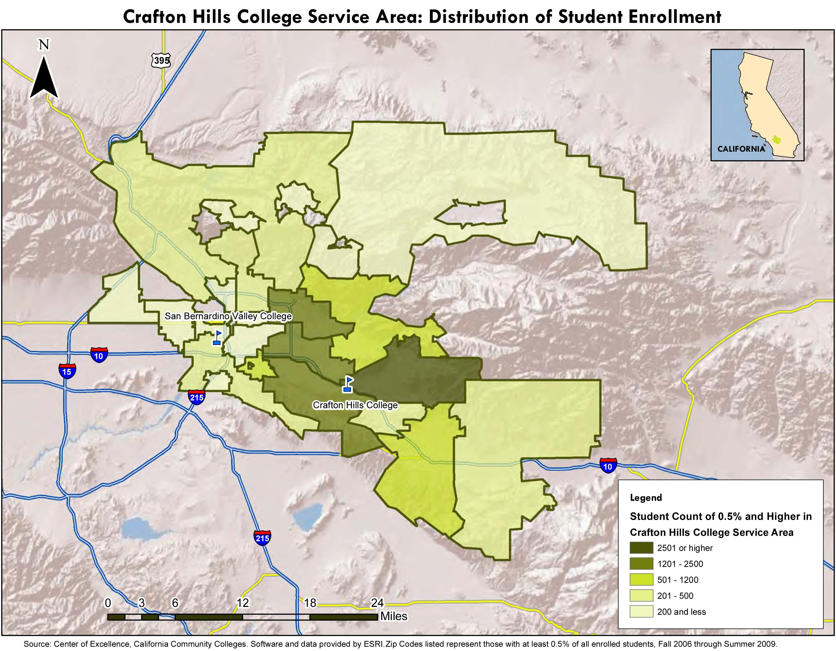
Figure 11.2
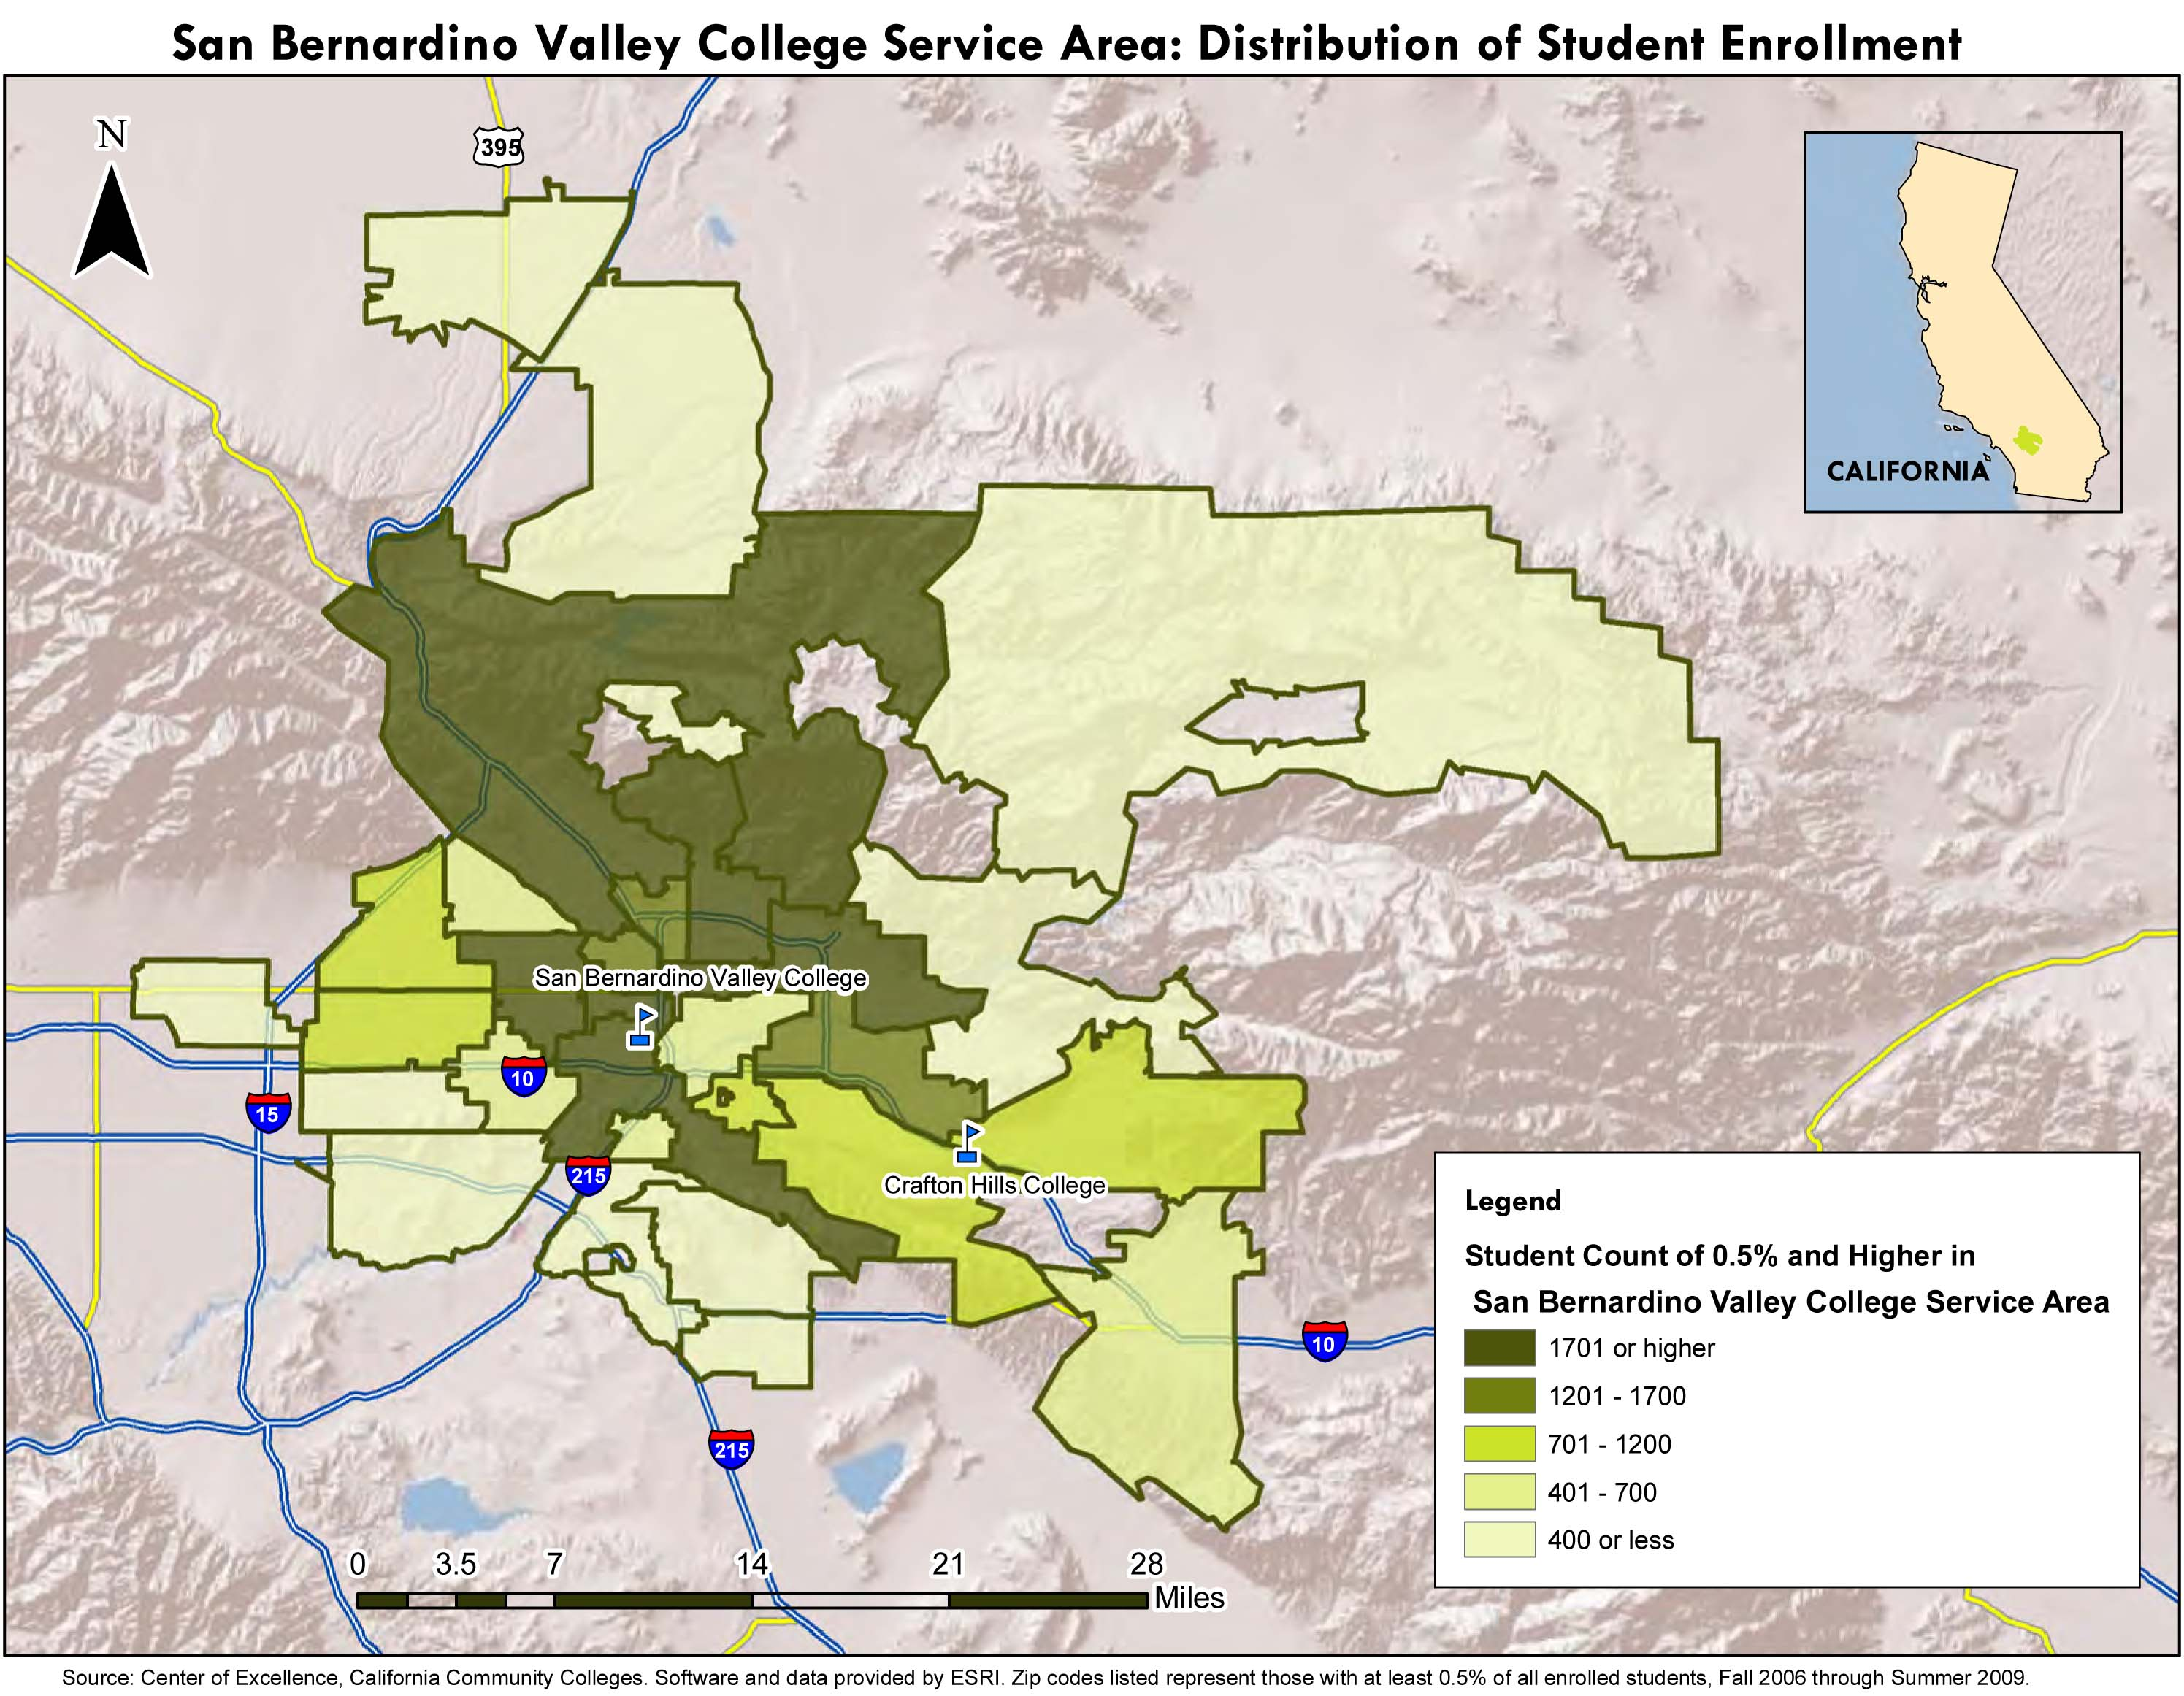

Figure 11.3
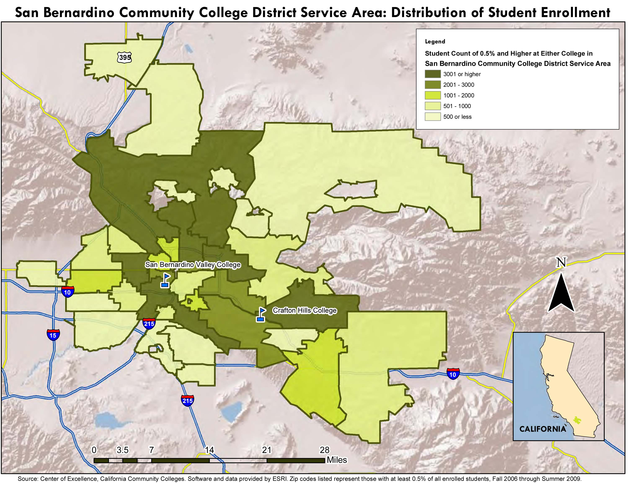

Figure 11.4
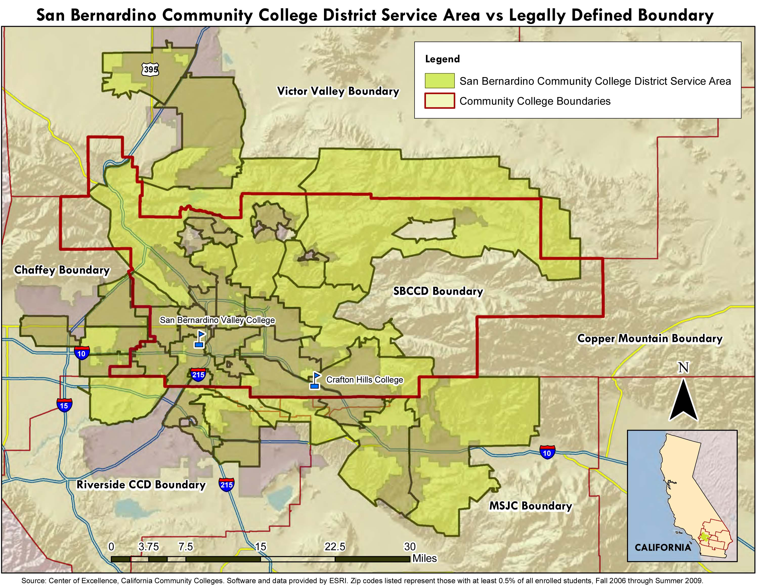

Figure 11.5
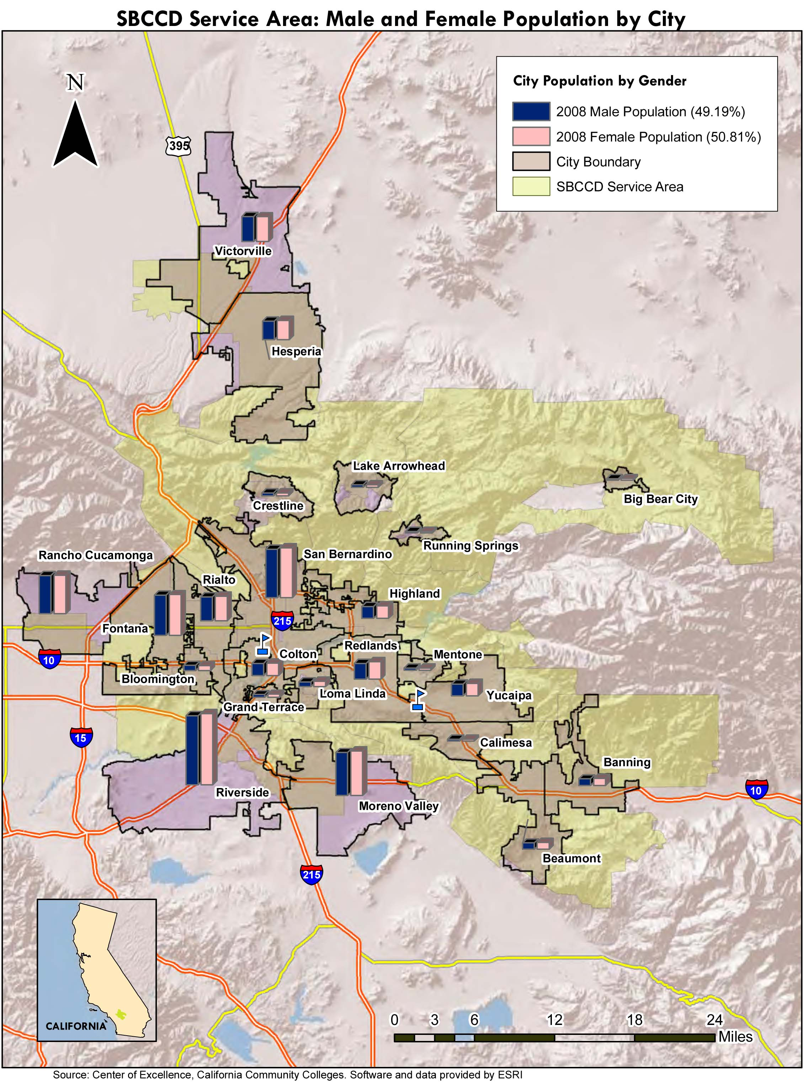
Figure 11.6
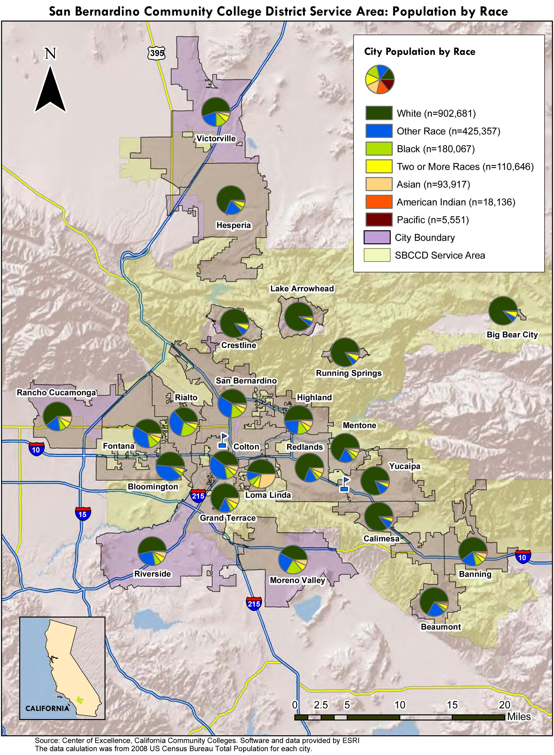

Figure 11.7
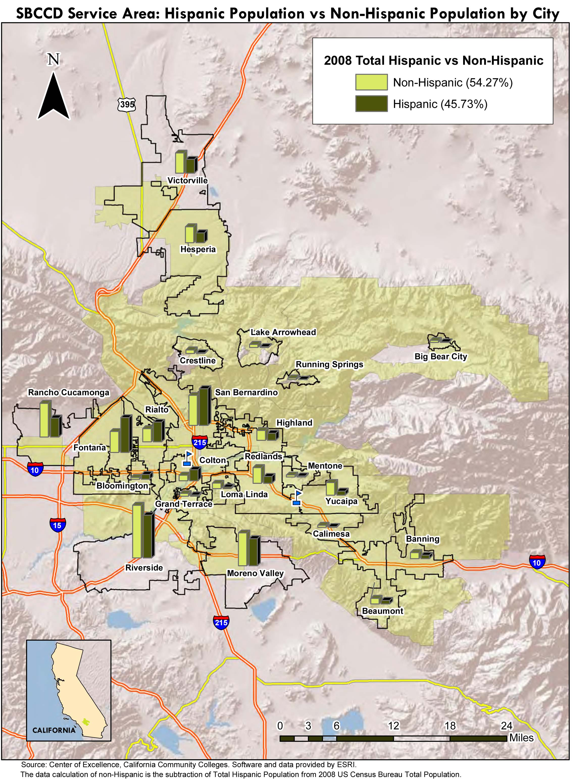
Figure 11.8
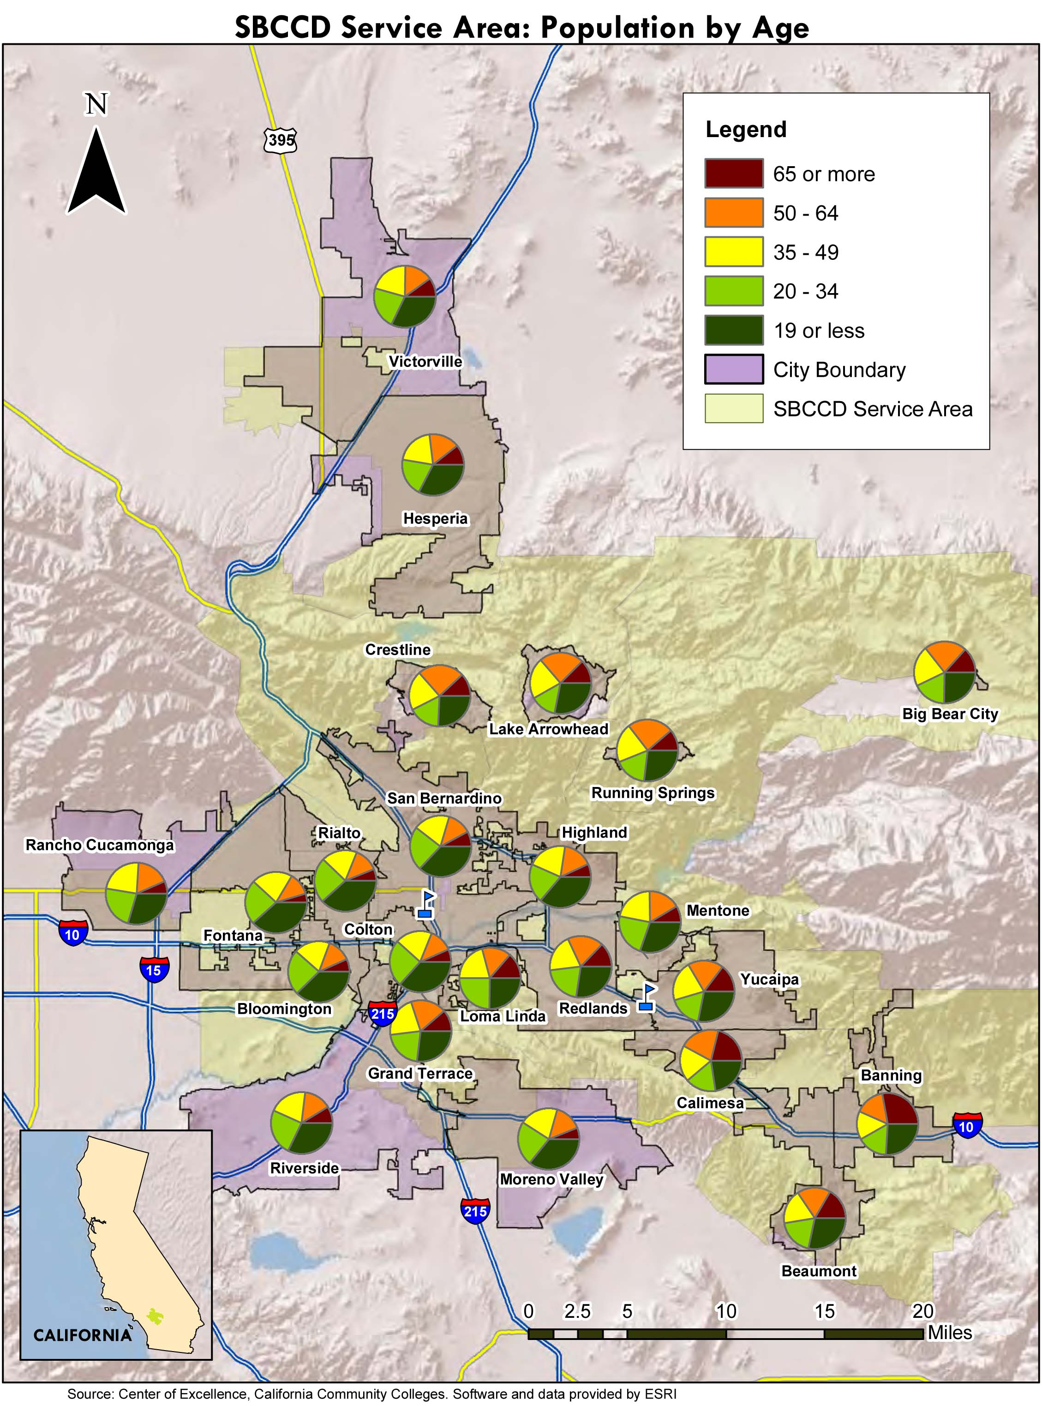

Figure 11.9
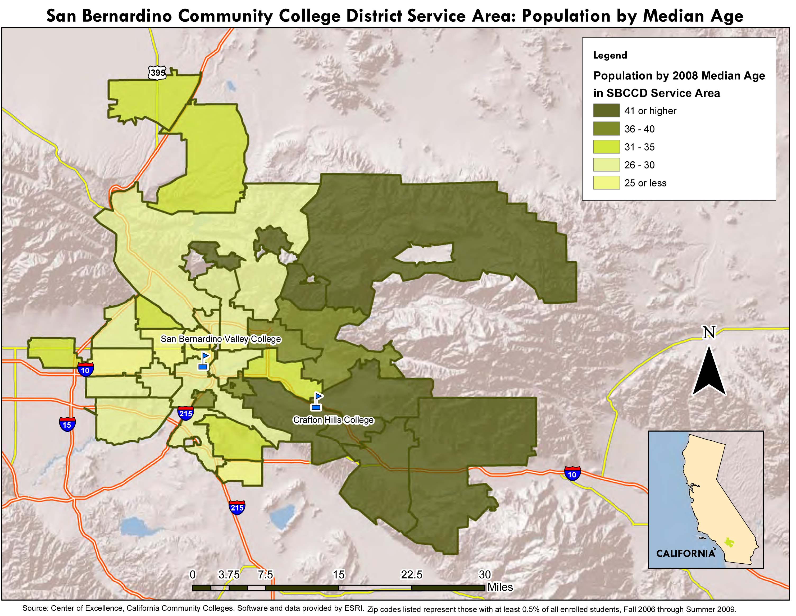

Figure 11.10
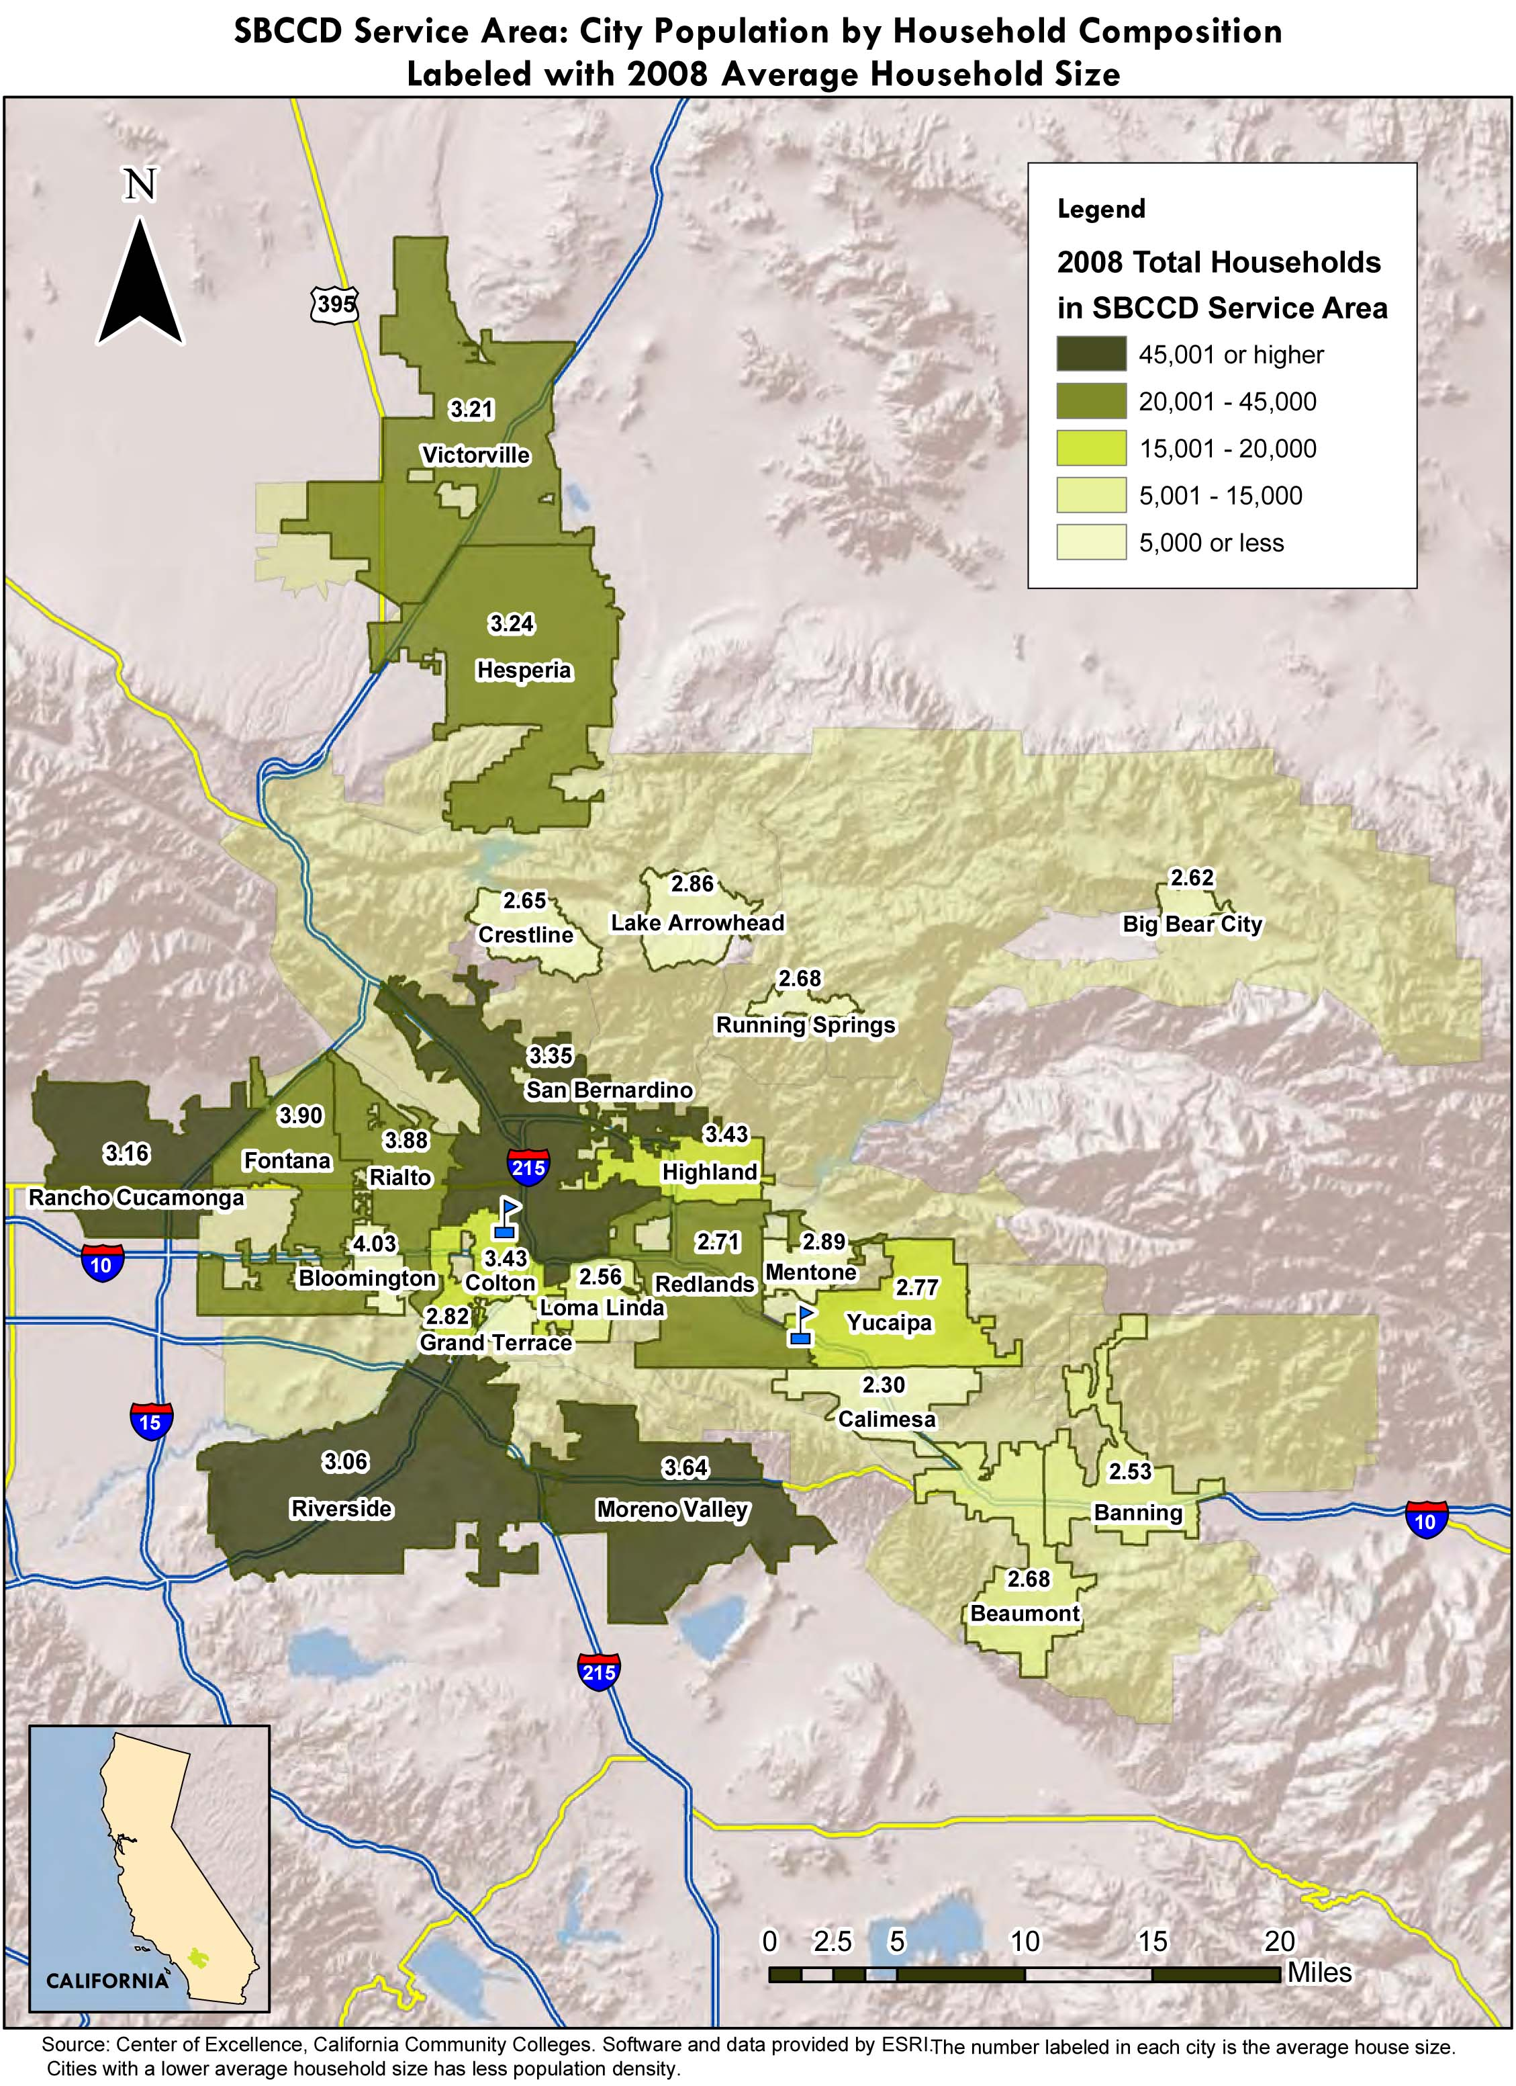

Figure 11.11
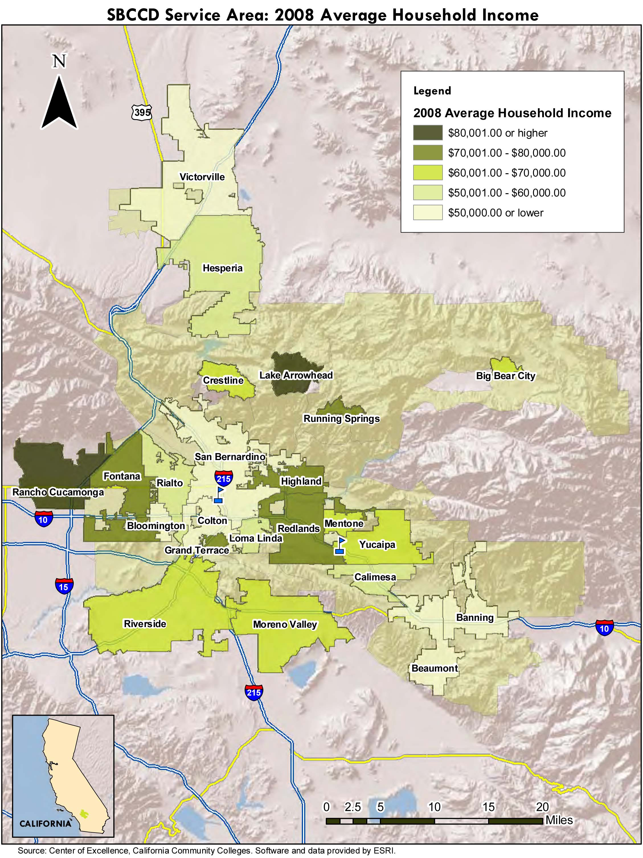

Figure 11.12
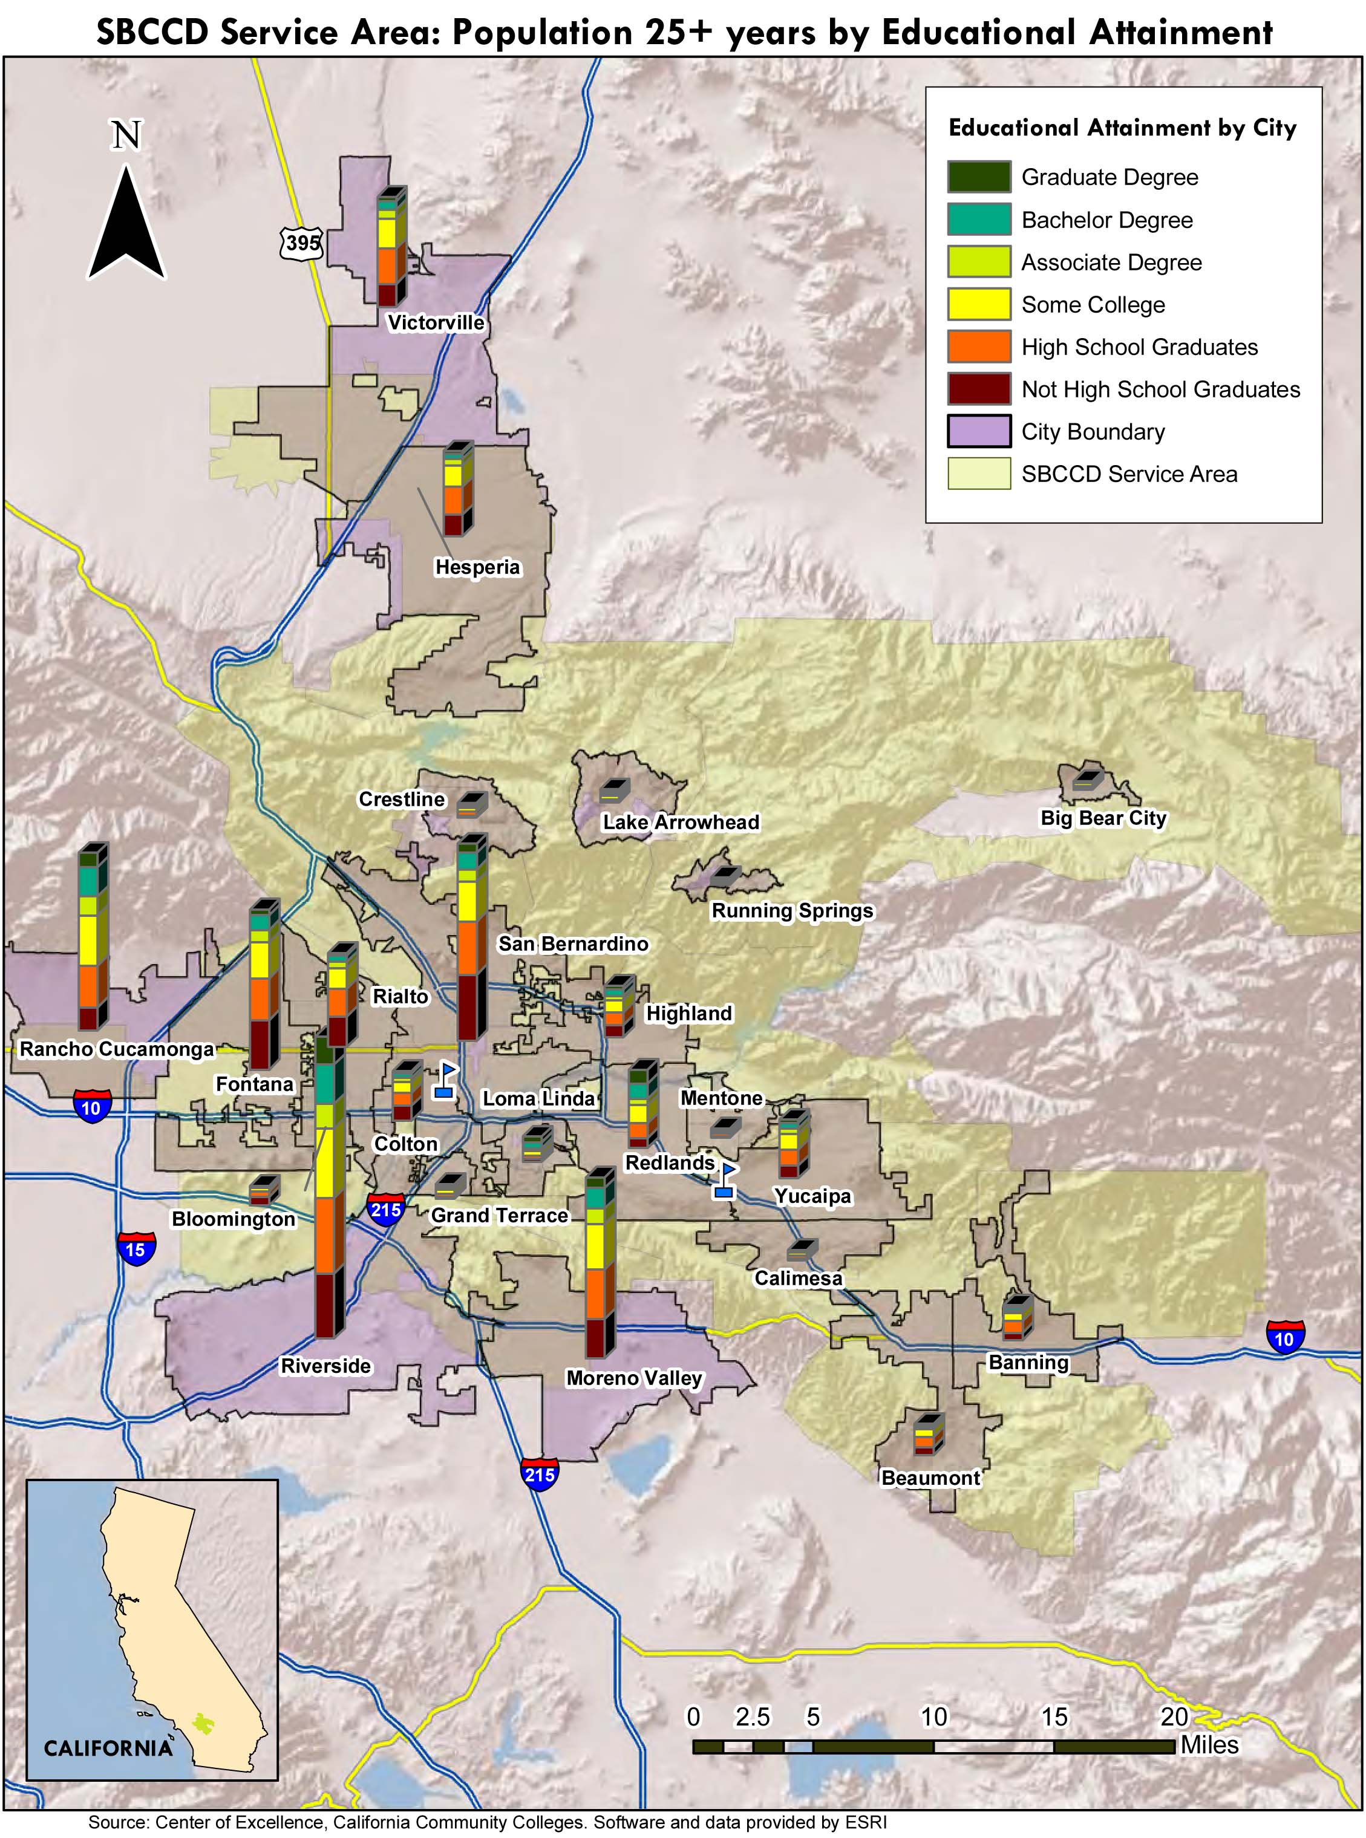

Figure 11.13
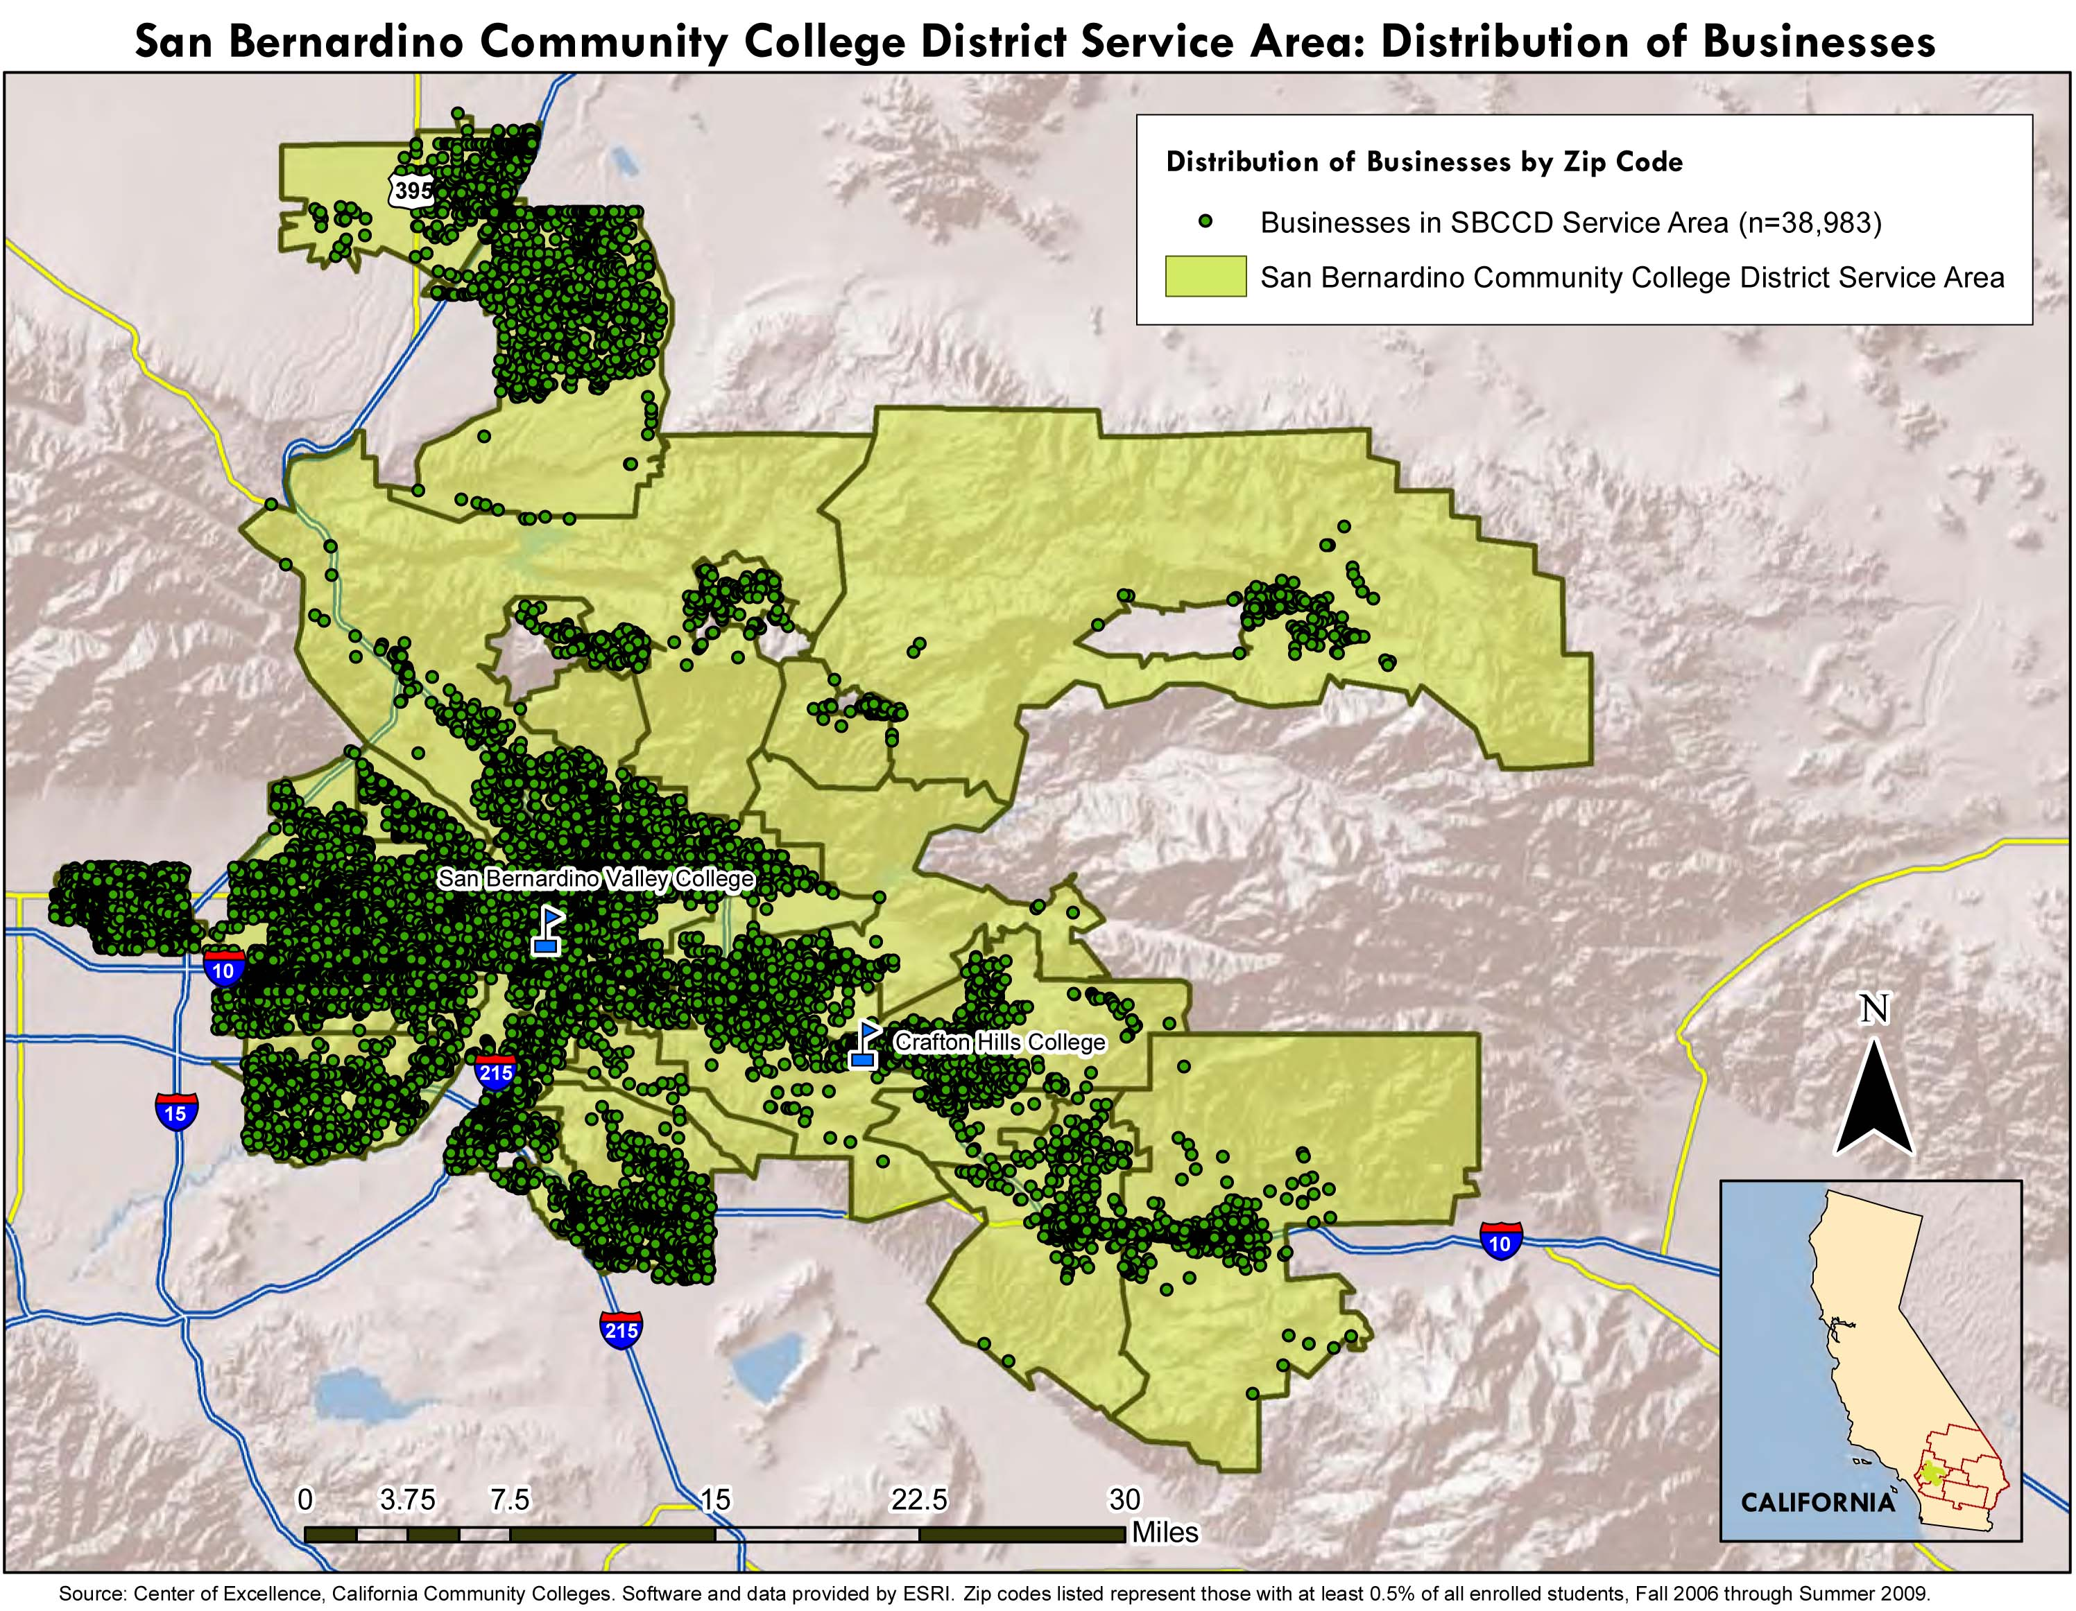

Figure 11.14
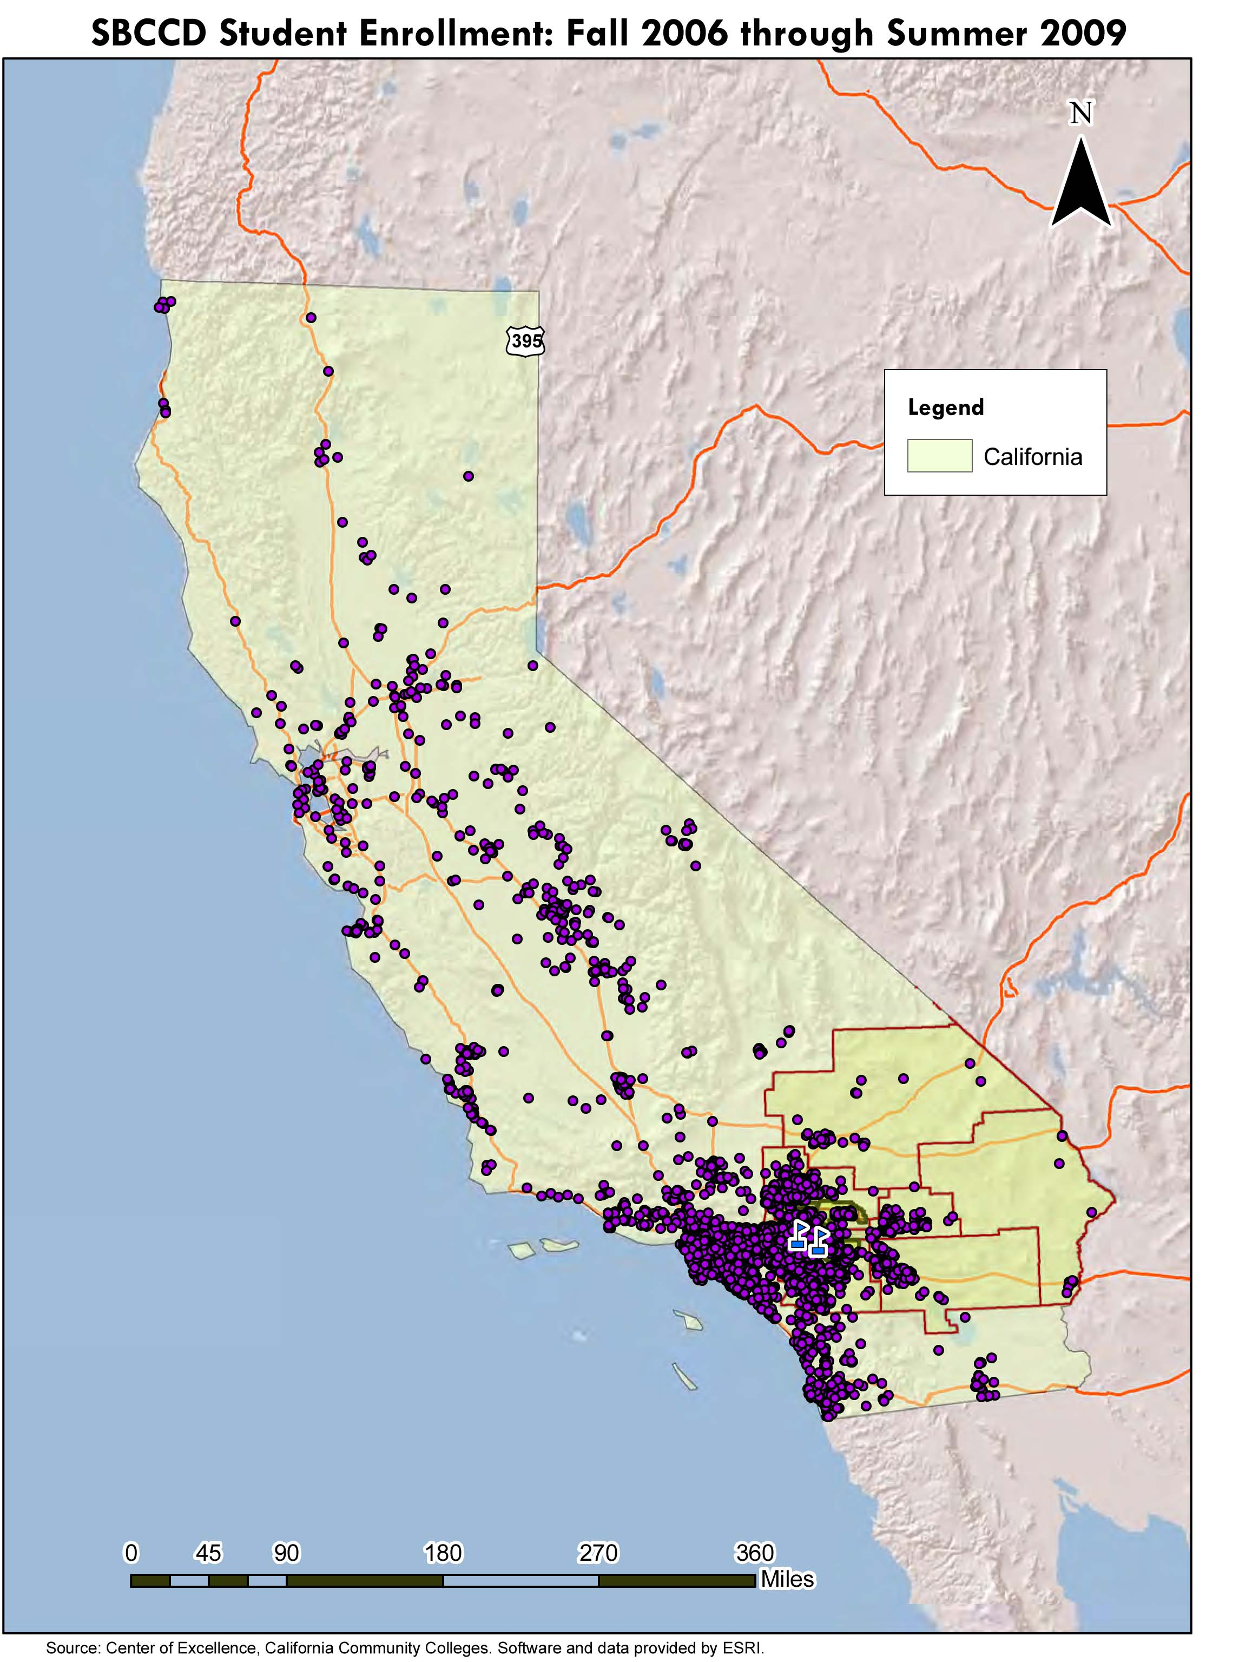

Table 11.1: Job Projections by Industry, 2008-13
San Bernardino and Riverside Counties
(Highlighted are the 10 fastest growing industries, by absolute number of new jobs in the Change column)

NAICS Code | NAICS Description / Industry | 2008 Jobs | 2013 Jobs | Change | % Change
11 | Agriculture, forestry, fishing and hunting | 6,201 | 5,571 | (630) | (10%)
11A | Crop and animal production | 3,832 | 3,372 | (460) | (12%)
113 | Forestry and logging | 9 | 9 | (0) | (1%)
114 | Fishing, hunting and trapping | 25 | 19 | (6) | (25%)
115 | Support activities for agriculture and forestry | 2,335 | 2,172 | (163) | (7%)
21 | Mining | 750 | 659 | (91) | (8%)
211 | Oil and gas extraction | 42 | 45 | 3 | 8%
212 | Mining, except oil and gas | 688 | 592 | (96) | (14%)
213 | Support activities for mining | 20 | 22 | 2 | 11%
22 | Utilities | 5,323 | 5,483 | 160 | 3%
221119 | Other electric power generation | 579 | 527 | (52) | (9%)
221122 | Electric power distribution | 358 | 397 | 39 | 11%
221210 | Natural gas distribution | 401 | 305 | (96) | (24%)
221310 | Water supply and irrigation systems | 3,921 | 4,509 | 588 | 15%
221320 | Sewage treatment facilities | 64 | n/a | n/a | n/a
23 | Construction | 93,930 | 84,446 | (9,484) | (10%)
236 | Construction of buildings | 24,517 | 21,575 | (2,942) | (12%)
237 | Heavy and civil engineering construction | 13,310 | 12,378 | (932) | (7%)
238 | Specialty trade contractors | 56,103 | 50,493 | (5,610) | (10%)
31-33 | Manufacturing | 105,541 | 99,254 | (6,287) | (6%)
311 | Food manufacturing | 6,545 | 7,069 | 524 | 8%
312 | Beverage and tobacco product manufacturing | 2,411 | 2,773 | 362 | 15%
313 | Textile mills | 534 | 571 | 37 | 7%
314 | Textile product mills | 568 | 534 | (34) | (6%)
315 | Apparel manufacturing | 273 | 232 | (41) | (15%)
316 | Leather and allied product manufacturing | 1,085 | 966 | (119) | (11%)
321 | Wood product manufacturing | 5,050 | 4,040 | (1,010) | (20%)
322 | Paper manufacturing | 2,527 | 2,401 | (126) | (5%)
323 | Printing and related support activities | 3,694 | 3,288 | (406) | (11%)
324 | Petroleum and coal products manufacturing | 563 | 569 | 6 | 1%
325 | Chemical manufacturing | 3,978 | 4,177 | 199 | 5%
326 | Plastics and rubber products manufacturing | 8,468 | 7,452 | (1,016) | (12%)
327 | Nonmetallic mineral product manufacturing | 4,902 | 4,314 | (588) | (12%)
331 | Primary metal manufacturing | 4,715 | 4,762 | 47 | 1%
332 | Fabricated metal product manufacturing | 18,138 | 16,324 | (1,814) | (10%)
333 | Machinery manufacturing | 5,776 | 5,314 | (462) | (8%)
334 | Computer and electronic product manufacturing | 6,224 | 6,597 | 373 | 6%
335 | Electrical equipment and appliance mfg. | 2,353 | 2,000 | (353) | (15%)
336 | Transportation equipment manufacturing | 8,280 | 7,286 | (994) | (12%)
337 | Furniture and related product manufacturing | 6,356 | 4,831 | (1,525) | (24%)
339 | Miscellaneous manufacturing | 13,101 | 13,756 | 655 | 5%
42 | Wholesale trade | 78,201 | 82,882 | 4,681 | 7%
423 | Merchant wholesalers, durable goods | 52,227 | 53,272 | 1,045 | 2%
424 | Merchant wholesalers, nondurable goods | 23,475 | 26,762 | 3,287 | 14%
425 | Electronic markets and agents and brokers | 2,499 | 2,849 | 350 | 14%
44-45 | Retail trade | 218,971 | 220,161 | 1,190 | 1%
441 | Motor vehicle and parts dealers | 36,738 | 33,799 | (2,939) | (8%)
442 | Furniture and home furnishings stores | 10,381 | 11,004 | 623 | 6%
443 | Electronics and appliance stores | 10,229 | 10,331 | 102 | 1%
444 | Building material and garden supply stores | 27,992 | 28,272 | 280 | 1%
445 | Food and beverage stores | 31,195 | 32,443 | 1,248 | 4%
446 | Health and personal care stores | 9,766 | 10,645 | 879 | 9%
447 | Gasoline stations | 4,782 | 4,447 | (335) | (7%)
448 | Clothing and clothing accessories stores | 16,618 | 16,950 | 332 | 2%
451 | Sporting goods, hobby, book and music stores | 8,630 | 8,026 | (604) | (7%)
452 | General merchandise stores | 40,280 | 41,488 | 1,208 | 3%
453 | Miscellaneous store retailers | 15,479 | 15,943 | 464 | 3%
454 | Nonstore retailers | 6,881 | 6,812 | (69) | (1%)
48-49 | Transportation and warehousing | 40,868 | 44,616 | 3,748 | 7%
481 | Air transportation | 227 | 261 | 34 | 15%
482 | Rail transportation | 161 | 164 | 3 | 2%
483 | Water transportation | 78 | 77 | (1) | (1%)
484 | Truck transportation | 15,521 | 16,452 | 931 | 6%
485 | Transit and ground passenger transportation | 5,760 | 5,990 | 230 | 4%
486 | Pipeline transportation | 641 | 603 | (38) | (6%)
487 | Scenic and sightseeing transportation | 301 | 415 | 114 | 38%
488 | Support activities for transportation | 11,451 | 13,512 | 2,061 | 18%
491 | Postal service | 3,307 | 3,439 | 132 | 4%
492 | Couriers and messengers | 449 | 462 | 13 | 3%
493 | Warehousing and storage | 2,972 | 3,239 | 267 | 9%
51 | Information | 16,104 | 16,746 | 642 | 4%
511 | Publishing industries, except Internet | 4,162 | 3,829 | (333) | (8%)
512 | Motion picture and sound recording industries | 2,929 | 2,812 | (117) | (4%)
515 | Broadcasting, except Internet | 2,518 | 2,795 | 277 | 11%
516 | Internet publishing and broadcasting | 0 | 0 | 0 | (13%)
517 | Telecommunications | 3,278 | 3,573 | 295 | 9%
518 | ISPs, search portals, and data processing | 1,158 | 1,204 | 46 | 4%
519 | Other information services | 2,059 | 2,533 | 474 | 23%
52 | Finance and insurance | 47,223 | 50,823 | 3,600 | 10%
521 | Monetary authorities - central bank | 0 | 0 | 0 | 0%
522 | Credit intermediation and related activities | 27,591 | 28,971 | 1,380 | 5%
523 | Securities, commodity contracts, investments | 5,426 | 6,348 | 922 | 17%
524 | Insurance carriers and related activities | 14,027 | 15,289 | 1,262 | 9%
525 | Funds, trusts, and other financial vehicles | 179 | 215 | 36 | 20%
53 | Real estate and rental and leasing | 52,723 | 60,255 | 7,532 | 15%
531 | Real estate | 44,306 | 51,838 | 7,532 | 17%
532 | Rental and leasing services | 8,412 | 8,412 | 0 | 0%
533 | Lessors of nonfinancial intangible assets | 5 | 5 | (0) | (5%)
54 | Professional and technical services | 63,654 | 70,656 | 7,002 | 11%
541110 | Offices of lawyers | 9,255 | 9,533 | 278 | 3%
541191 | Title abstract and settlement offices | 2,193 | 2,127 | (66) | (3%)
541199 | All other legal services | 1,098 | 1,142 | 44 | 4%
541211 | Offices of certified public accountants | 2,010 | 2,030 | 20 | 1%
541213 | Tax preparation services | 3,162 | 3,573 | 411 | 13%
541214 | Payroll services | 364 | 484 | 120 | 33%
541219 | Other accounting services | 1,781 | 1,870 | 89 | 5%
541310 | Architectural services | 2,023 | 2,003 | (20) | (1%)
541320 | Landscape architectural services | 786 | 817 | 31 | 4%
541330 | Engineering services | 8,874 | 8,697 | (177) | (2%)
541340 | Drafting services | 151 | 151 | 0 | 0%
541350 | Building inspection services | 401 | 473 | 72 | 18%
541370 | Other surveying and mapping services | 532 | 468 | (64) | (12%)
541380 | Testing laboratories | 744 | 781 | 37 | 5%
541410 | Interior design services | 1,216 | 1,192 | (24) | (2%)
541420 | Industrial design services | 10 | 8 | (2) | (22%)
541430 | Graphic design services | 1,169 | 1,216 | 47 | 4%
541490 | Other specialized design services | 839 | 1,158 | 319 | 38%
541511 | Custom computer programming services | 2,462 | 3,348 | 886 | 36%
541512 | Computer systems design services | 938 | 910 | (28) | (3%)
541519 | Other computer related services | 289 | 332 | 43 | 15%
541611 | Administrative management consulting services | 206 | 264 | 58 | 28%
541612 | Human resource consulting services | 865 | 649 | (216) | (25%)
541613 | Marketing consulting services | 1,646 | 1,761 | 115 | 7%
541614 | Process and logistics consulting services | 1,785 | 1,839 | 54 | 3%
541618 | Other management consulting services | 1,871 | 917 | (954) | (51%)
541620 | Environmental consulting services | 31 | 34 | 3 | 10%
541690 | Other technical consulting services | 829 | 1,152 | 323 | 39%
541711 | Research and development in biotechnology | 2,179 | n/a | n/a | n/a
541712 | R&D in physical, engineering, & life sciences | 3 | n/a | n/a | n/a
541720 | Social science and humanities research | 215 | 269 | 54 | 25%
541810 | Advertising agencies | 876 | 797 | (79) | (9%)
541820 | Public relations agencies | 160 | 176 | 16 | 10%
541840 | Media representatives | 483 | 565 | 82 | 17%
541850 | Display advertising | 406 | 434 | 28 | 7%
541860 | Direct mail advertising | 848 | 611 | (237) | (28%)
541870 | Advertising material distribution services | 4,221 | 3,124 | (1,097) | (26%)
541890 | Other services related to advertising | 909 | 1,191 | 282 | 31%
541910 | Marketing research and public opinion polling | 499 | 554 | 55 | 11%
541921 | Photography studios, portrait | 1,267 | 1,394 | 127 | 10%
541922 | Translation and interpretation services | 230 | 150 | (81) | (35%)
54 | Professional and technical services (continued)
541930 | Translation and interpretation services | 80 | 94 | 14 | 17%
541940 | Veterinary services | 2,172 | 2,324 | 152 | 7%
541990 | All other professional and technical services | 1,576 | 1,324 | (252) | (16%)
55 | Management of companies and enterprises | 1,350 | 1,310 | (41) | (3%)
551111 | Offices of bank holding companies | 602 | 680 | 78 | 13%
551112 | Offices of other holding companies | 748 | 621 | (127) | (17%)
56 | Administrative and waste services | 44,984 | 49,033 | 4,049 | 9%
561 | Administrative and support services | 41,577 | 45,319 | 3,742 | 9%
562 | Waste management and remediation services | 3,407 | 3,714 | 307 | 9%
61 | Educational services | 122,671 | 145,978 | 23,307 | 19%
611110 | Elementary and secondary schools | 100,032 | 119,038 | 19,006 | 19%
611210 | Junior colleges | 129 | 141 | 12 | 9%
611310 | Colleges, universities, and professional schools | 16,314 | 19,251 | 2,937 | 18%
611410 | Business and secretarial schools | 1,042 | 771 | (271) | (26%)
611420 | Computer training | 161 | 127 | (34) | (21%)
611430 | Management training | 95 | 90 | (5) | (5%)
611511 | Cosmetology and barber schools | 316 | 325 | 9 | 3%
611512 | Flight training | 112 | 131 | 19 | 17%
611519 | Other technical and trade schools | 505 | 651 | 146 | 29%
611610 | Fine arts schools | 774 | 735 | (39) | (5%)
611620 | Sports and recreation instruction | 1,277 | 1,494 | 217 | 17%
611630 | Language schools | 8 | 6 | (2) | (27%)
611691 | Exam preparation and training | 869 | 1,130 | 261 | 30%
611692 | Automobile driving schools | 283 | 325 | 42 | 15%
611699 | Miscellaneous schools and instruction | 327 | 405 | 78 | 24%
611710 | Educational support services | 427 | 483 | 56 | 13%
62 | Health care and social assistance | 146,854 | 168,565 | 21,711 | 15%
621 | Ambulatory health care services | 60,464 | 69,534 | 9,070 | 15%
622 | Hospitals | 49,527 | 56,461 | 6,934 | 14%
623 | Nursing and residential care facilities | 19,079 | 21,941 | 2,862 | 15%
624 | Social assistance | 17,784 | 20,629 | 2,845 | 16%
71 | Arts, entertainment, and recreation | 35,723 | 40,998 | 5,275 | 14%
711 | Performing arts and spectator sports | 3,313 | 3,677 | 364 | 11%
712 | Museums, historical sites, zoos, and parks | 4,582 | 5,040 | 458 | 10%
713 | Amusements, gambling, and recreation | 27,828 | 32,280 | 4,452 | 16%
72 | Accommodation and food services | 137,710 | 151,819 | 14,109 | 11%
721 | Accommodation | 25,286 | 24,780 | (506) | (2%)
722 | Food services and drinking places | 112,424 | 127,039 | 14,615 | 13%
81 | Other services, except public administration | 117,278 | 121,583 | 4,305 | 7%
811 | Repair and maintenance | 24,309 | 25,281 | 972 | 4%
812 | Personal and laundry services | 26,497 | 23,847 | (2,650) | (10%)
813 | Membership associations and organizations | 66,472 | 72,454 | 5,982 | 9%
90 | Government | 61,986 | 68,804 | 6,818 | 11%
921 | Executive, legislative, and other general government | 24,883 | n/a | n/a | n/a
922 | Justice, public order, and safety activities | 23,881 | n/a | n/a | n/a
923 | Administration of human resource programs | 6,615 | n/a | n/a | n/a
924 | Administration of environmental quality programs | 858 | n/a | n/a | n/a
925 | Adm. of housing, urban planning, & community dev. | 734 | n/a | n/a | n/a
926 | Administration of economic programs | 4,266 | n/a | n/a | n/a
928 | National security and international affairs | 749 | n/a | n/a | n/a
99 | All Other | 9,870 | 10,956 | 1,086 | 11%
 | All Industries TOTAL | 1,261,488 | 1,332,517 | 71,029 | 5.6%
Sources: InfoUSA 2008, EMSI Complete Employment - 4th Quarter 2009

Table 11.2: Occupational Projections, 2008-13
San Bernardino and Riverside Counties
(Sorted by 2013 jobs; only the top 50 occupations are included. Highlighted are 10 fastest growing occupations by % change.)

SOC Code | Description | 2008 Jobs | 2013 Jobs | Change (New Jobs) | % Change | New & Rep. Jobs | % New & Rep. | Avg EPW* | Education Level
41-2031 | Retail salespersons | 55,157 | 57,459 | 2,302 | 4% | 10,016 | 18% | $12.73 | Short-term on-the-job training
41-2011 | Cashiers, except gaming | 37,717 | 37,961 | 244 | 1% | 9,292 | 25% | $10.42 | Short-term on-the-job training
39-9011 | Child care workers | 31,993 | 37,044 | 5,051 | 16% | 9,721 | 30% | $8.98 | Short-term on-the-job training
43-9061 | Office clerks, general | 33,362 | 35,744 | 2,382 | 7% | 5,268 | 16% | $13.16 | Short-term on-the-job training
53-7062 | Laborers and freight, stock, and material movers, hand | 34,106 | 34,826 | 720 | 2% | 5,701 | 17% | $12.11 | Short-term on-the-job training
35-3021 | Combined food preparation and serving workers, including fast food | 28,807 | 32,852 | 4,045 | 14% | 6,700 | 23% | $8.95 | Short-term on-the-job training
37-2012 | Maids and housekeeping cleaners | 27,004 | 30,778 | 3,774 | 14% | 6,307 | 23% | $9.03 | Short-term on-the-job training
53-3032 | Truck drivers, heavy and tractor-trailer | 28,597 | 30,006 | 1,409 | 5% | 3,731 | 13% | $21.10 | Moderate-term on-the-job training
25-2021 | Elementary school teachers, except special education | 24,899 | 28,192 | 3,293 | 13% | 5,962 | 24% | $40.13 | Bachelor's degree
41-1011 | First-line supervisors/managers of retail sales workers | 27,320 | 27,749 | 429 | 2% | 3,056 | 11% | $17.79 | Work experience in a related field
41-9022 | Real estate sales agents | 23,036 | 27,221 | 4,185 | 18% | 5,900 | 26% | $9.34 | Postsecondary vocational award
41-9021 | Real estate brokers | 22,269 | 26,429 | 4,160 | 19% | 5,819 | 26% | $9.05 | Work experience in a related field
29-1111 | Registered nurses | 20,914 | 24,313 | 3,399 | 16% | 5,154 | 25% | $35.75 | Associate's degree
43-5081 | Stock clerks and order fillers | 24,533 | 24,235 | (298) | (1%) | 3,590 | 15% | $11.65 | Short-term on-the-job training
35-3031 | Waiters and waitresses | 20,421 | 23,096 | 2,675 | 13% | 8,033 | 39% | $9.71 | Short-term on-the-job training
55-9999 | Military Occupations | 22,682 | 22,634 | (48) | 0% | 2,676 | 12% | $20.60 | N/A
47-2061 | Construction laborers | 22,397 | 20,772 | (1,625) | (7%) | 663 | 3% | $20.52 | Moderate-term on-the-job training
43-3031 | Bookkeeping, accounting, and auditing clerks | 18,990 | 20,180 | 1,190 | 6% | 2,581 | 14% | $16.68 | Moderate-term on-the-job training
47-2031 | Carpenters | 21,386 | 18,833 | (2,553) | (12%) | 1,104 | 5% | $27.29 | Long-term on-the-job training
11-1021 | General and operations managers | 18,358 | 18,600 | 242 | 1% | 2,283 | 12% | $48.50 | Degree plus work experience
43-4051 | Customer service representatives | 16,246 | 18,489 | 2,243 | 14% | 4,395 | 27% | $15.77 | Moderate-term on-the-job training
37-3011 | Landscaping and groundskeeping workers | 16,612 | 18,118 | 1,506 | 9% | 2,539 | 15% | $11.44 | Short-term on-the-job training
37-2011 | Janitors and cleaners, except maids and housekeeping cleaners | 16,802 | 17,900 | 1,098 | 7% | 2,645 | 16% | $12.79 | Short-term on-the-job training
11-9141 | Property, real estate, and community association managers | 15,101 | 17,656 | 2,555 | 17% | 3,529 | 23% | $10.74 | Bachelor's degree
43-1011 | First-line supervisors/managers of office and administrative support workers | 16,272 | 17,075 | 803 | 5% | 2,385 | 15% | $22.49 | Work experience in a related field
35-2011 | Cooks, fast food | 15,024 | 16,474 | 1,450 | 10% | 3,409 | 23% | $8.87 | Short-term on-the-job training
25-9041 | Teacher assistants | 14,485 | 15,988 | 1,503 | 10% | 2,659 | 18% | $16.79 | Short-term on-the-job training
11-9199 | Managers, all other | 15,130 | 15,779 | 649 | 4% | 2,045 | 14% | $20.89 | Work experience in a related field
53-3033 | Truck drivers, light or delivery services | 14,585 | 15,618 | 1,033 | 7% | 2,228 | 15% | $16.92 | Short-term on-the-job training
43-6011 | Executive secretaries and administrative assistants | 14,213 | 15,404 | 1,191 | 8% | 2,263 | 16% | $19.53 | Moderate-term on-the-job training
25-1099 | Postsecondary teachers | 12,779 | 15,368 | 2,589 | 20% | 3,675 | 29% | $38.63 | Doctoral degree
25-2031 | Secondary school teachers, except special and vocational education | 13,413 | 14,675 | 1,262 | 9% | 3,209 | 24% | $39.09 | Bachelor's degree
49-9042 | Maintenance and repair workers, general | 12,683 | 13,454 | 771 | 6% | 918 | 7% | $17.92 | Moderate-term on-the-job training
53-7064 | Packers and packagers, hand | 13,794 | 13,368 | (426) | (3%) | 1,558 | 11% | $10.90 | Short-term on-the-job training
39-9021 | Personal and home care aides | 10,513 | 12,842 | 2,329 | 22% | 3,248 | 31% | $9.41 | Short-term on-the-job training
41-4012 | Sales representatives, wholesale and manufacturing, except technical and scientific products | 11,917 | 12,672 | 755 | 6% | 1,976 | 17% | $31.57 | Moderate-term on-the-job training
13-2011 | Accountants and auditors | 11,550 | 12,659 | 1,109 | 10% | 2,103 | 18% | $20.93 | Bachelor's degree
25-3099 | Teachers and instructors, all other | 10,951 | 12,271 | 1,320 | 12% | 1,894 | 17% | $27.13 | Bachelor's degree
11-1011 | Chief executives | 10,904 | 11,447 | 543 | 5% | 1,906 | 17% | $30.62 | Degree plus work experience
31-1012 | Nursing aides, orderlies, and attendants | 9,735 | 11,316 | 1,581 | 16% | 2,024 | 21% | $11.75 | Postsecondary vocational award
33-9032 | Security guards | 10,292 | 11,276 | 984 | 10% | 2,013 | 20% | $11.40 | Short-term on-the-job training
53-7051 | Industrial truck and tractor operators | 11,207 | 11,257 | 50 | 0% | 1,456 | 13% | $15.42 | Short-term on-the-job training
43-6014 | Secretaries, except legal, medical, and executive | 10,874 | 11,156 | 282 | 3% | 1,096 | 10% | $15.13 | Moderate-term on-the-job training
41-9091 | Door-to-door sales workers, news and street vendors, and related workers | 11,416 | 11,058 | (358) | (3%) | 725 | 6% | $8.13 | Short-term on-the-job training
13-1199 | Business operation specialists, all other | 9,536 | 10,987 | 1,451 | 15% | 1,953 | 20% | $29.67 | Bachelor's degree
51-2092 | Team assemblers | 10,889 | 10,795 | (94) | (1%) | 1,001 | 9% | $11.54 | Moderate-term on-the-job training
35-1012 | First-line supervisors/managers of food preparation and serving workers | 9,560 | 10,682 | 1,122 | 12% | 1,470 | 15% | $13.69 | Work experience in a related field
43-5071 | Shipping, receiving, and traffic clerks | 10,121 | 10,516 | 395 | 4% | 1,516 | 15% | $14.02 | Short-term on-the-job training
47-1011 | First-line supervisors/managers of construction trades and extraction workers | 11,306 | 10,332 | (974) | (9%) | 620 | 5% | $32.44 | Work experience in a related field
41-1012 | First-line supervisors/managers of non-retail sales workers | 9,432 | 9,894 | 462 | 5% | 1,092 | 12% | $26.82 | Work experience in a related field
Source: EMSI Complete Employment - 4th Quarter 2009
* EPW = Earnings per worker

Glossary

Term | Definition
A&R | Admissions and Records
ACCJC | Accrediting Commission for Community and Junior Colleges
Accreditation | The process by which a college is reviewed by a group of peers on behalf of an official accreditation agency, to determine the extent to which the college meets specific accepted standards of excellence. Each college seeks, as a result of this process, to obtain formal acknowledgement as accredited.
ARCC | Accountability Reporting for Community Colleges, a program administered by the CCCCO to gather and publish systemwide and college-specific performance data
ARRA | American Recovery and Reinvestment Act, the legal name of the federal economic stimulus program
Assessment | The systematic collection of information about student learning, and about activities and functions that support such learning, both directly and indirectly, and the use of that information to create a continuing cycle of improved teaching and learning at the Institutional, Program and Course levels.
Career Pathways | An approach to K-12 and higher education that systematically creates links between academic and career fields, often with the help of business and governmental partners. In the California Community Colleges System Strategic Plan, this approach is one of the strategies for achieving Goal C, Partnerships for Economic and Workforce Development.
CCCCO | California Community Colleges Chancellor’s Office
CHC | Crafton Hills College
Cohort | A group of people sharing certain characteristics, often tracked through time for research purposes. ARCC and many other studies of community college students use a cohort design.
Collegial Consultation | The process by which the District provides faculty, students, staff, and management the opportunity to participate effectively in district and college governance in accord with Title 5, California Code of Regulations, sections 51023.5, 51023.7, 53200, and 53203. Collegial consultation often involves committees on which the constituency groups are represented.
Constituency Group | One of the groups that participate in collegial consultation. In SBCCD, that includes the Academic Senates, Student Senates, Classified Senates, CSEA, and the management teams.
CSEA | California State Employees Association, the classified union in SBCCD
CTA | California Teachers Association, the faculty union in SBCCD
DETS | Distributed Education and Technology Services
District | Generally refers to the District as a whole and all the entities that comprise it: SBVC, CHC, the District Office, KVCR, and EDCT/PDC.
District Assembly | The District’s shared decision-making council comprised of members selected by each constituency group.
District Office(s) | Also called the Central Office, the centralized functions of the District: the Chancellor’s Office, Fiscal Services, Human Resources, and Distributed Education and Technology Services (DETS). Also refers to the south wing of the administration building, where all these functions are housed, except for DETS, which is housed at the District Annex.
District Resource Allocation Model | The overall process by which funds are allocated to the campuses and District Office operations.
DOE | US Department of Education
DSP | District Strategic Plan
DSP&S | Disabled Students Programs and Services
DSPC | District Strategic Planning Committee
EDCT | Economic Development and Corporate Training
Educational Master Plan | A long-term outline (usually three to five years) of the programs and services that a college will undertake to facilitate student learning directly or indirectly; typically includes how the college will prioritize the instructional and service offerings based on an assessment of data related to enrollment, job markets, and other information. May function as the college’s strategic plan, or integrate with the strategic plan.
EMP | Educational Master Plan
EOP&S | Extended Opportunity Programs and Services
FTEF | Full-time Equivalent Faculty, also known as Faculty Load
FTES | Full-time Equivalent Students, the primary measure used by the State in funding community colleges. One FTES is the equivalent of one student taking courses totaling 15 hours per week each semester for two semesters.
Institutional Effectiveness | The measure of our overall success as an educational operation. It is based on a systematic, continuous and documented evaluation of institutional performance in relation to institutional purpose.
KVCR | District-owned public radio and television stations
Message Deck | A document that outlines key messages on key organizational issues and delineates which will be communicated to each target audience. The suggested Message Deck document would provide approved language to ensure message consistency, and would serve as the primary reference for all the organization’s communications, from press releases and brochures to publications and community event talking points.
PDC | Professional Development Center, a division of EDCT.
Program | Generic term for a specific set of institutional activities or functions considered as a unit for the purposes of assessment.
Program Review | A process by which a program or service regularly evaluates its efficacy. Its purpose is continuous improvement of the program or service. It is evidence-based, involves input from constituency groups and advisory committees, and results in a report that includes planned improvements.
SAO | Service Area Outcome
SBCCD | San Bernardino Community College District
SBVC | San Bernardino Valley College
SLO | Student Learning Outcome
WASC | Western Association of Schools and Colleges, the regional accrediting body of which the ACCJC is a part.

